Meadow High School
Royal Lane, Hillingdon, Middlesex UB8 3QU

Telephone: (01895) 443310
Email: meadow@meadowhighschool.org
Website: www.meadowhighschool.org

Headteacher: Mrs Jenny Rigby
Deputy Headteacher (Royal Lane): Miss Michelle Taylor
Deputy Headteacher (Northwood Road): Miss Amy Willis
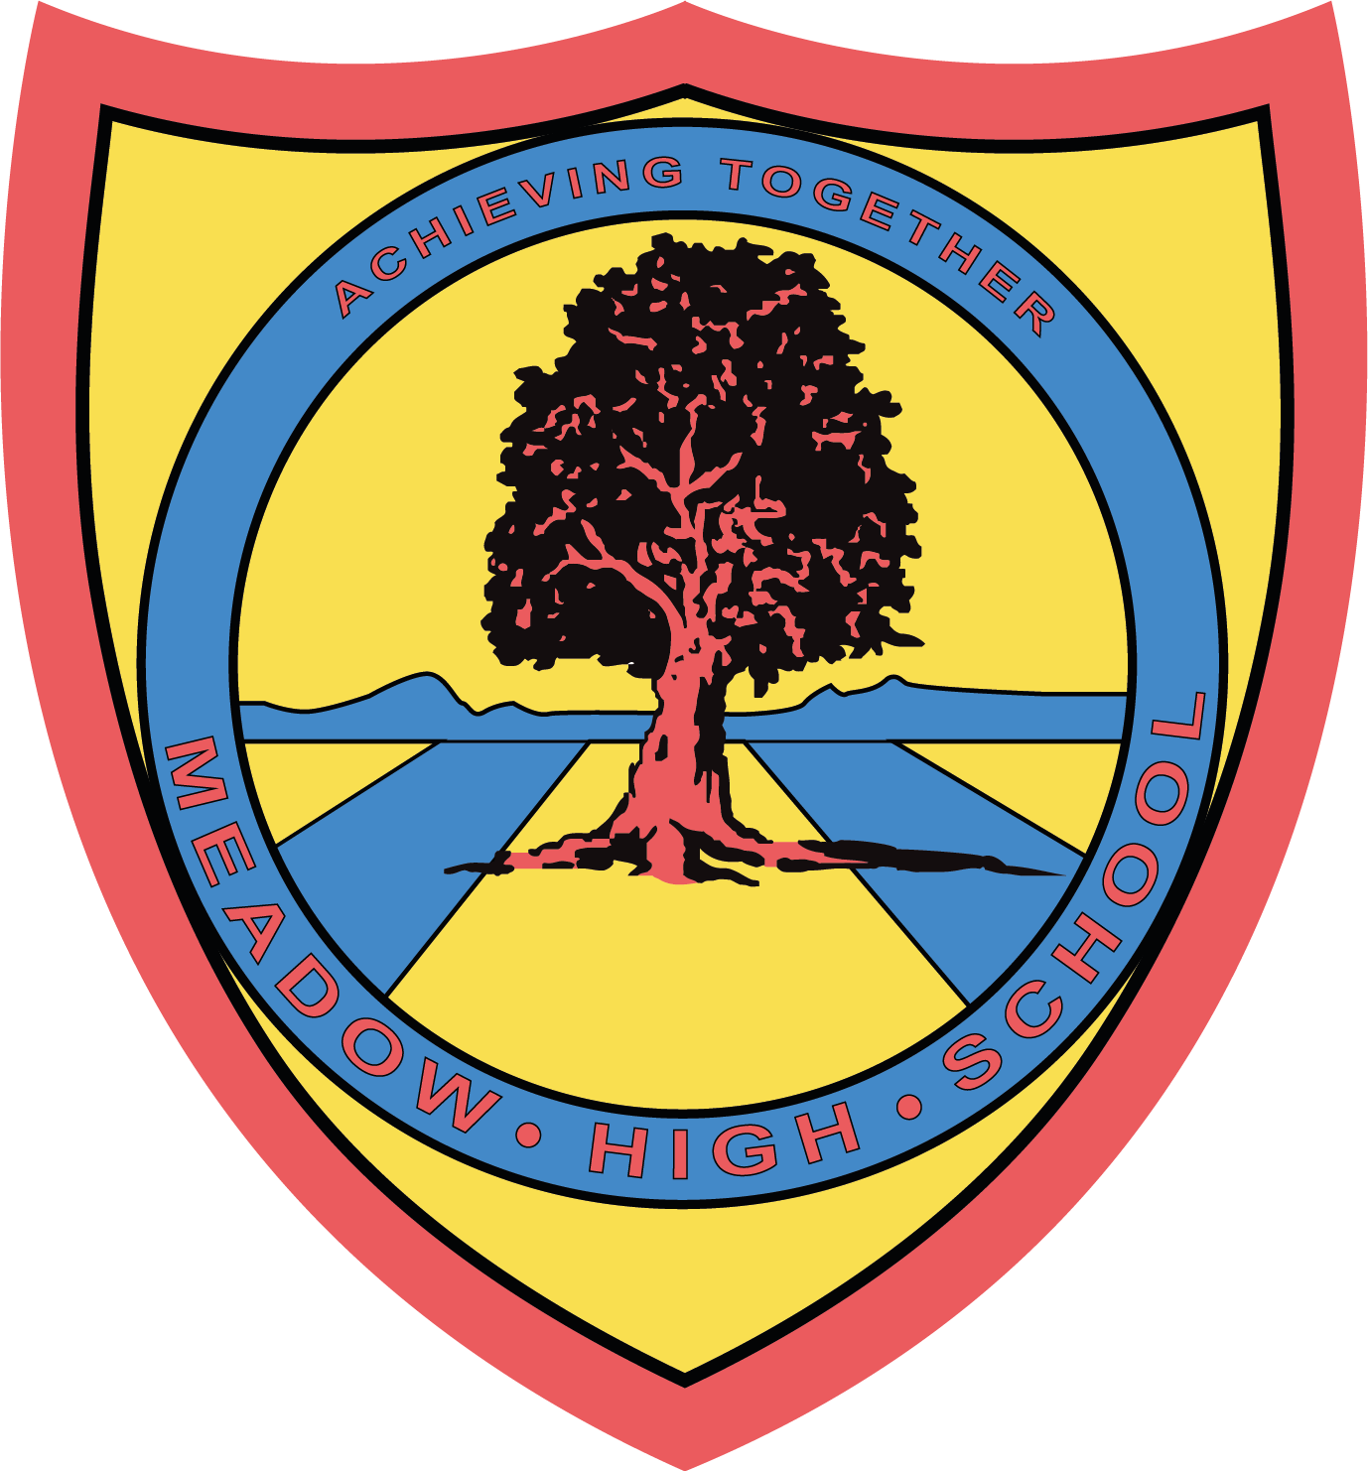

19th September 2024

Dear Parents/Carers,

As part of PE lessons, pupils in Class SM will be having swimming lessons starting on 26th September 2024 until 19th December 2024. Pupils will travel by minibus to Windsor Leisure Centre and be taught by qualified swim instructors. Members of the staff from the class team will also be in the water to support.

Swimming lessons will take place every Thursday. Pupils will require a suitable swimming costume/shorts, a towel and any other personal preferences when swimming such as googles. I also suggest sending in an extra snack and drink as swimming can make you hungry.
Yours sincerely,


Faye Bonnar
Assistant Head Teacher Pathway 1

Article 23:- 'A child with a disability has the right to live a full and decent life with dignity and independence, and to play an active part in the community.'



