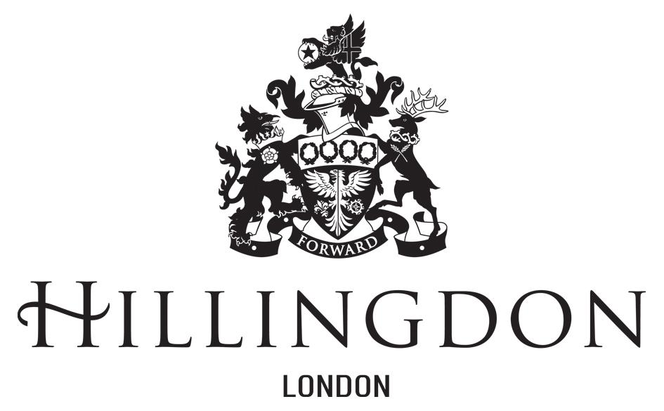

**YEAR 6 2024-25 Bikeability Level 1&2 - Meadow High (AM ONLY)**

Dear Parent/Guardian

On behalf of your child’s school, I am writing to invite your child to a safer cycling course, which will enable them to complete Levels 1 and 2 combined.

**Course Information:**

The course will run for 4 days for 2 hours each session.

* Trainees **MUST** be able to ride a bike at a basic level of competence unaided. To include, cycle in a straight line, cycle one handed (L & R), use brakes to slow-down/stop.
* Trainees attending the Bikeability course must have their own bike or use a suitable bike Trainees must attend all sessions(unless they are unsuccessful in Level 1). The bike **MUST** be roadworthy or they will not be able to take part in the course. Please view the [TFL Quick Cycle Safety Check](https://youtu.be/VdYvIrIVlcc) and [LB of Hillingdon Cycle Check](https://youtu.be/P1XESgAnSLk) to help.

| Monday 17th March 2025 | Level 1 | 9:30 – 11:30 |
| --- | --- | --- |
| Tuesday 18th March 2025 | Level 2 | 9:30 – 11:30 |
| Wednesday 19th March 2025 | Level 2 | 9:30 – 11:30 |
| Thursday 20th March 2025 | Level 2 | 9:30 – 11:30 |

You can apply for your child to attend this course by completing the online booking form via the link below. **This form must be completed for your child to be registered to take part in the course!**

[Online Bikeability Booking Form](https://forms.gle/eUhkxB3T2LaX18Zf6)

Applicants will be registered on a first come first serve basis.

Yours sincerely,

**Ian Ramsay**

Ian Ramsay

**Borough Cycle Support Officer**

*To find out more about Bikeability visit* [*https://bikeability.org.uk/*](https://bikeability.org.uk/)