***Meadow High School***

*Royal Lane, Hillingdon, Middlesex UB8 3QU*

*Telephone: (01895) 443310*

*Email: meadow@meadowhighschool.org*

*Website: www.meadowhighschool.org*

***Headteacher: Mrs Jenny Rigby***

***Deputy Headteacher (Royal Lane): Miss Michelle Taylor***

***Deputy Headteacher (Northwood Road): Miss Amy Willis***

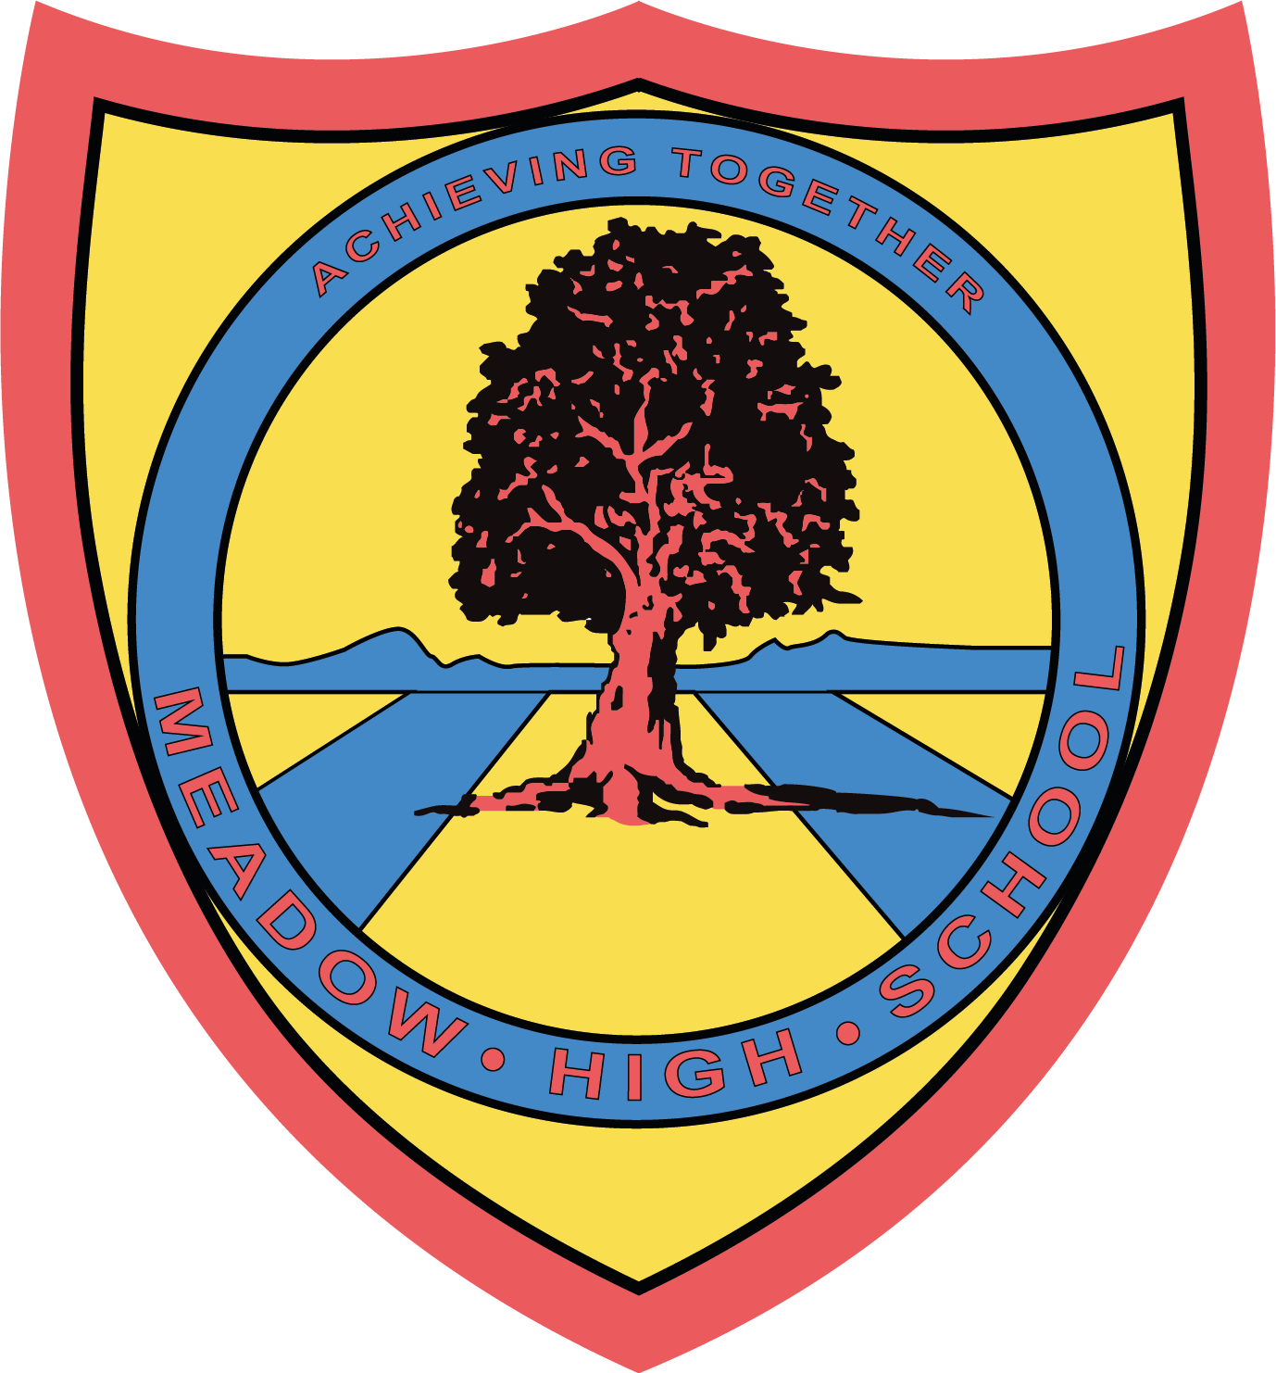

September 2024

Dear Parent/Carer,

In Food Technology in Year 7, the students will be focusing on health and safety while making bread based dishes. This term students will be making:

* Easy Pizza
* Bread and Butter Pudding
* Crunchy Hot Dogs
* Apple Charlotte
* Festival Project

Students also taste and evaluate a range of foods. We will also provide a suitable container for the food that they have made to be taken home in.

If you wish for your child to take the products that he/she prepares, the amount required for all practical lessons will be **£7.50** using your Parent Pay account.

If you require any assistance with your Parent Pay account, please contact the school reception for support.

Thank you in advance.

**Mrs P. Shukla**

**Food Technology Department**

***Article 23:- 'A child with a disability has the right to live a full and decent life with dignity and independence, and to play an active part in the community.'***

