Meadow High School
Royal Lane, Hillingdon, Middlesex UB8 3QU

Telephone: (01895) 443310
Email: meadow@meadowhighschool.org
Website: www.meadowhighschool.org

Headteacher: Mrs Jenny Rigby
Deputy Headteacher (Royal Lane): Miss Michelle Taylor
Deputy Headteacher (Northwood Road): Miss Amy Willis
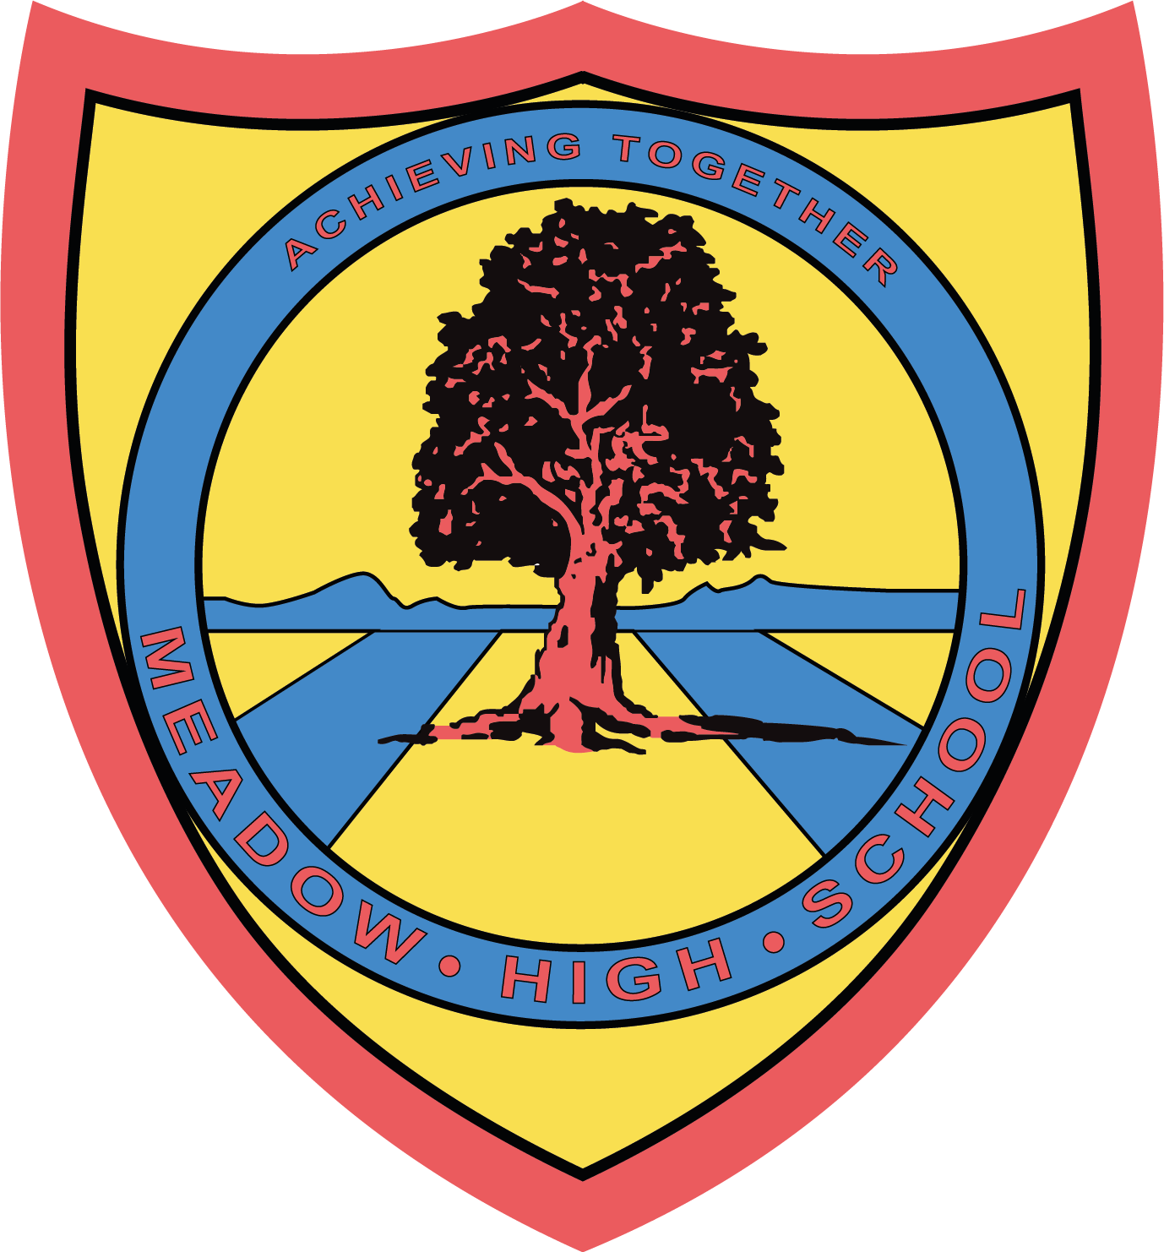

Monday 24th March 2025

Dear Parents / Carers,

Your young person is in year 14 so is in their final year at Meadow High School. The school year for leavers ends following the leavers assembly on Friday 27th June. You will be invited to attend this year's assembly in person where students will be presented with their record of achievement. They are not required to attend school following this date and we have no facility for pupils to attend beyond this date.

In addition, following this date there will be some optional events, such as prom, a BBQ and a leavers trip that young people are invited to attend if they wish.

More information about the events will be shared in due course.

Thank-you for your understanding.

Kind Regards,


Amy Willis
Deputy Head- Pathway 1/ Northwood Road
Meadow High School
awillis@meadowhighschool.org
01895 443310 ext: 201

Article 23:- 'A child with a disability has the right to live a full and decent life with dignity and independence, and to play an active part in the community.'



