Meadow High School
Royal Lane, Hillingdon, Middlesex UB8 3QU

Telephone: (01895) 443310
Email: meadow@meadowhighschool.org
Website: www.meadowhighschool.org

Headteacher: Mrs Jenny Rigby
Deputy Headteacher (Royal Lane): Miss Michelle Taylor
Deputy Headteacher (Northwood Road): Miss Amy Willis
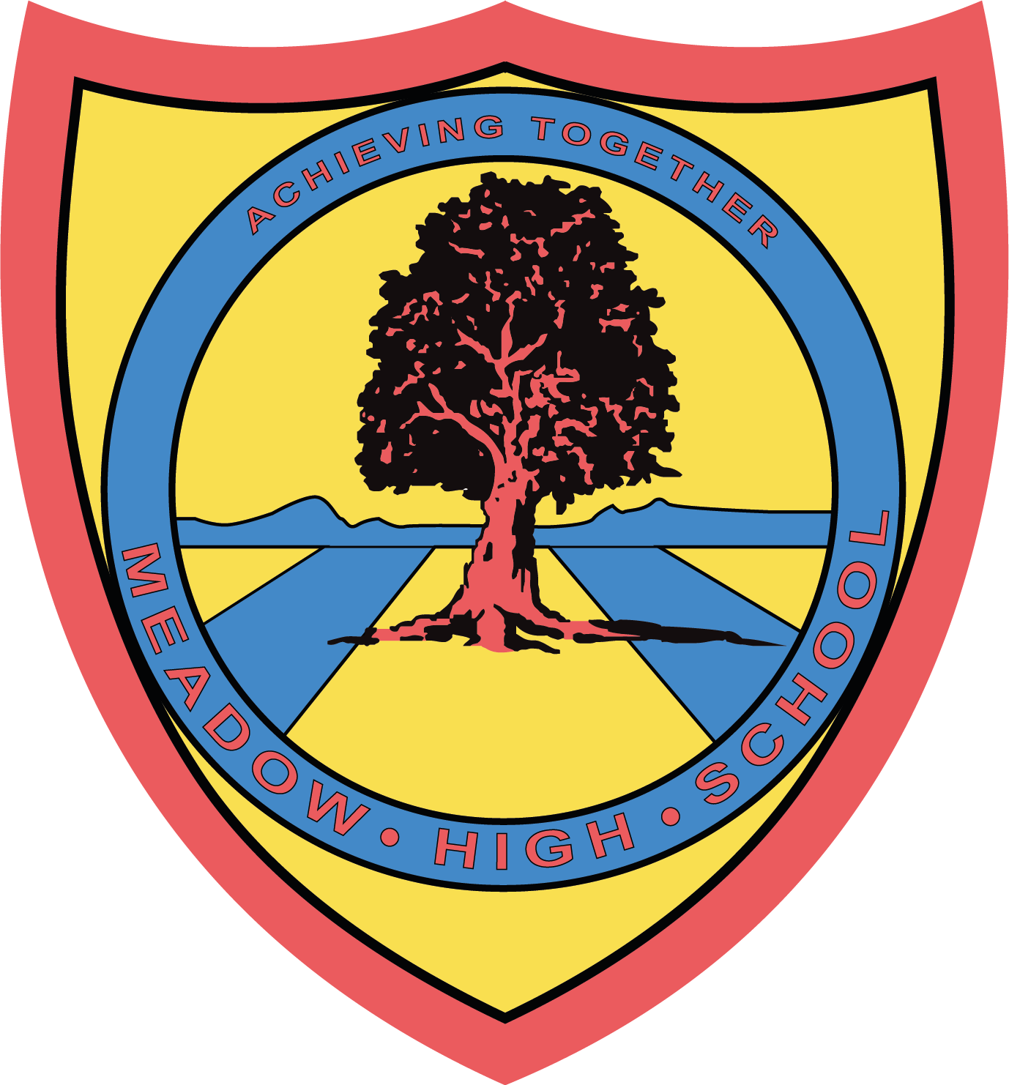

19 November 2024
Dear Parents/Carer,

Christmas Afternoon Tea – 9 December 2024

On Monday 9th December, Pathway 1 are hosting a Christmas Afternoon Tea at 2pm.

Parents and Carers are invited to join the pupils and staff for Mince Pies, hot drinks and storytelling.

Please return the reply-slip confirming attendance and if you wish to take your child home with you afterwards. Parking is not allowed in the school car park. The event will finish promptly at 2.50pm.

We hope you can join us.

Many thanks,

Hayley O’Neill
Assistant Head Pathway 1
Article 23:- 'A child with a disability has the right to live a full and decent life with dignity and independence, and to play an active part in the community.'


--------------------------------------------------------------------------------------------------------------------------------
Reply Slip – PW1 Afternoon Tea – 9 December 2024

Pupils name: ____________________________ Class:_____________

I will be attending the Christmas Afternoon Tea on 9th December and my child will go home as normal.

I will be attending the Christmas Afternoon Tea on 9th December and will take my child home at 2.50pm.

Unfortunately, I cannot attend.

Signed _____________________________

Name: ____________________________

