Meadow High School
Royal Lane, Hillingdon, Middlesex UB8 3QU

Telephone: (01895) 443310
Email: meadow@meadowhighschool.org
Website: www.meadowhighschool.org

Headteacher: Mrs Jenny Rigby
Deputy Headteacher (Royal Lane): Miss Michelle Taylor
Deputy Headteacher (Northwood Road): Miss Amy Willis
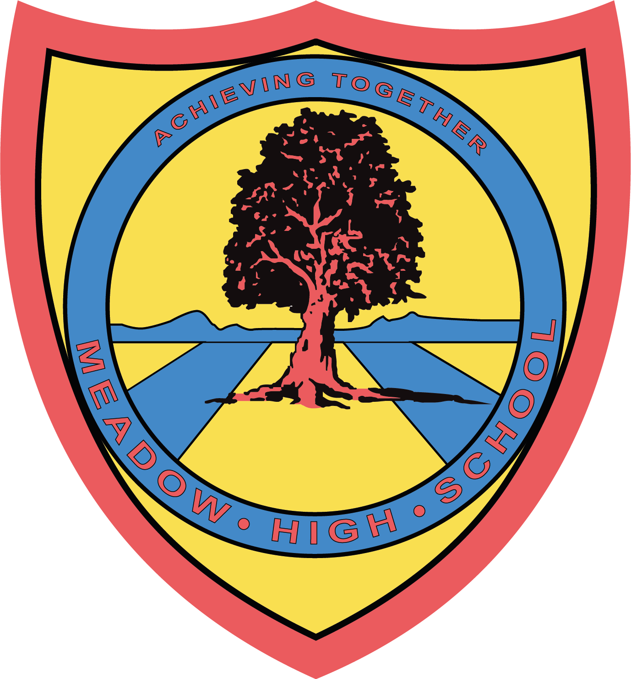

Monday 25th November 2024

Dear Parent/Carer,

We are very excited to announce that from Tuesday 3rd December till Friday 6th December we will be running a Scholastic Book Fair in our Library, just in time for Christmas!

The Scholastic Book Fair is a pop-up celebration of reading that puts the very best books directly into your child’s hands, all while raising rewards to spend on free books and essential resources for our school! For every sale made, Meadow High School will receive 50% in FREE rewards that we can use for even more resources for our students!

We will be hosting two parent coffee afternoons on:

One session on Tuesday 3rd December:
- 3.15pm till 4.15pm

Two sessions on Thursday 5th December:
- 1.40pm till 2.40pm
- 3.15pm till 4.15pm

These will give you the opportunity to visit the Fair with your child and choose some of the fantastic books that will be on offer! You can pay online at our parent coffee afternoons via card using our school’s unique QR code that will be displayed in the Library for the duration of the fair.

If you are not able to attend one of our parent coffee afternoons, you also have the option of purchasing a gift voucher for your child that they can use to cover the cost of the books they choose from the Fair. You can find the range of gift vouchers via the Scholastic website here: https://bookfairs.scholastic.co.uk/gift-vouchers. Please note that if you purchase a gift voucher this must be printed and your child must bring it into school with them during the fair, otherwise they will not be able to buy any books. Please also note that any gift vouchers purchased will expire on Saturday 7th December, one day after the fair finishes.

If you would like to join us at one of the parent coffee afternoons, please fill out the reply slip below and return it to your child’s form tutor. If you have any questions, please contact our Librarian, Miss S Gaafar, on sgaafar@meadowhighschool.org.

Kind Regards,

Miss S Gaafar
Librarian (Supporting and Delivering Learning)

Reply-Slip: Scholastic Book Fair: Parents Coffee Afternoon Sessions 03.12.24 and 05.12.24

After school sessions:
( ) I would like to attend the Tuesday 3rd December 3.15pm - 4.15pm session.
( ) I would like to attend the Thursday 5th December 3.15pm - 4.15pm session.
During school session:
( ) I would like to attend the Thursday 5th December 1.40m - 2.40pm session.
( ) I will be collecting my child at the end of the session [at 2.40pm]

Child’s Name: __________________________________________ Class: ____________________

Signed: _________________________________________________________________

PRINT NAME: ___________________________________________________________

