Meadow High School
Royal Lane, Hillingdon, Middlesex UB8 3QU

Telephone: (01895) 443310
Email: meadow@meadowhighschool.org
Website: www.meadowhighschool.org

Headteacher: Mrs Jenny Rigby
Deputy Headteacher (Royal Lane): Miss Michelle Taylor
Deputy Headteacher (Northwood Road): Miss Amy Willis
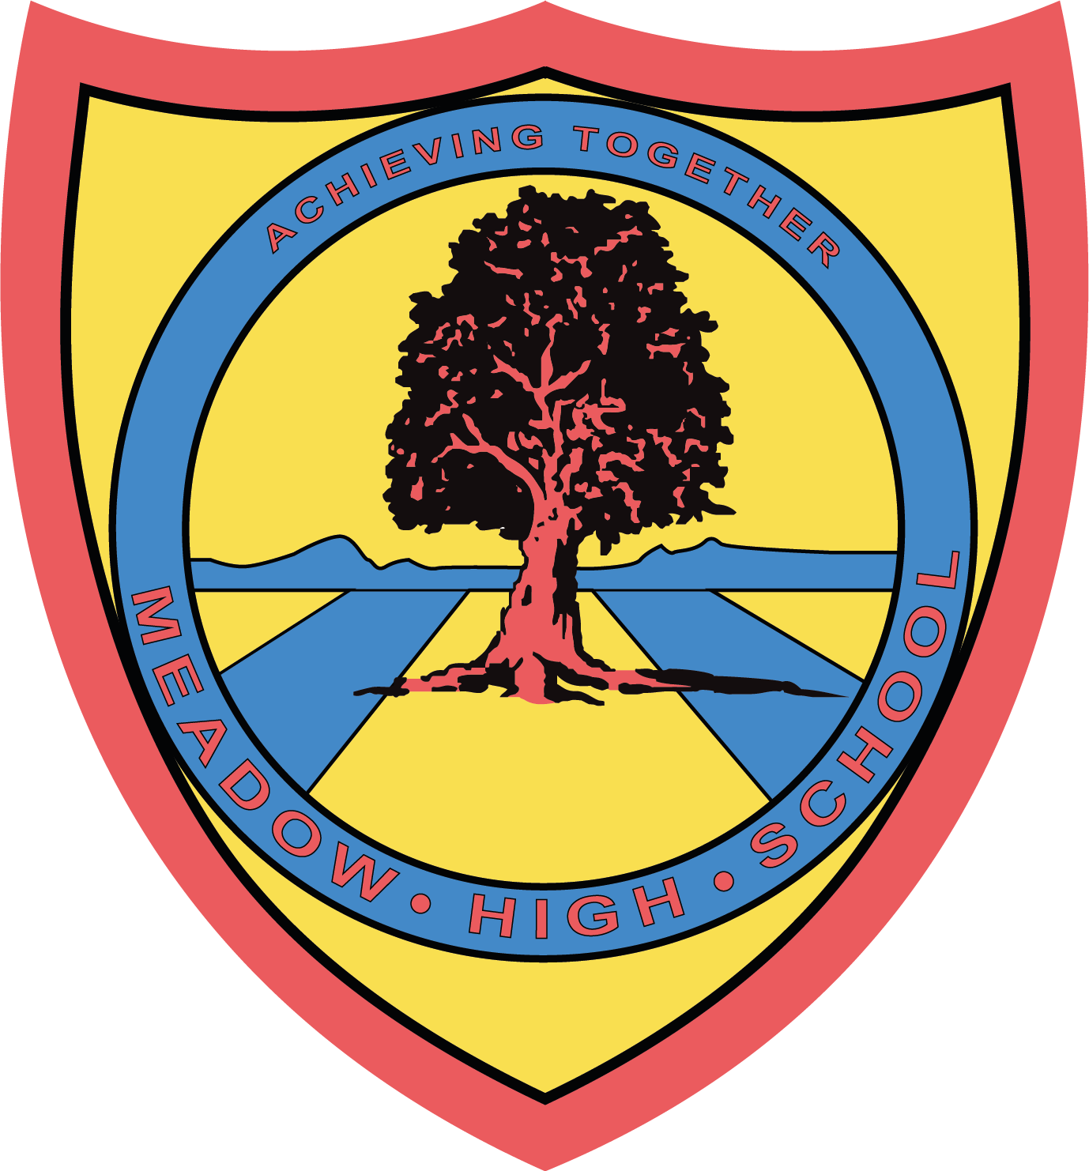

7th March 2025

Dear Parents/ Careers,

Football Tournament

Your child has been selected to attend a Football Event on Tuesday, 11th March 2025.

The event will take place between 10:00 – 15:00.

On the day, your child should come into school in their PE kit with shin pads. They will also need to bring a healthy packed lunch, as lunch will not be provided at the event. If your child is entitled to a free school meal, then we can provide a packed lunch (please indicate on reply-slip below if you require a lunch.

Please note that your child will be picked up from school at the usual time of 15:05.

If you have any questions or concerns, feel free to reach out.

Kind regards,

Mr. Anstee
PE Faculty Lead

Article 23:- 'A child with a disability has the right to live a full and decent life with dignity and independence, and to play an active part in the community.'



Reply-Slip – Football Tournament – please return to Mr Anstee

My child _______________________________________ is entitled to a free school meal and would like lunch provided.
Choice of sandwich: cheese ( ) tuna mayo ( ) egg mayo ( )

Signed (Parent/Carer): __________________________________

