Meadow High School
Royal Lane, Hillingdon, Middlesex UB8 3QU

Telephone: (01895) 443310
Email: meadow@meadowhighschool.org
Website: www.meadowhighschool.org

Headteacher: Mrs Jenny Rigby
Deputy Headteacher (Royal Lane): Miss Michelle Taylor
Deputy Headteacher (Northwood Road): Miss Amy Willis
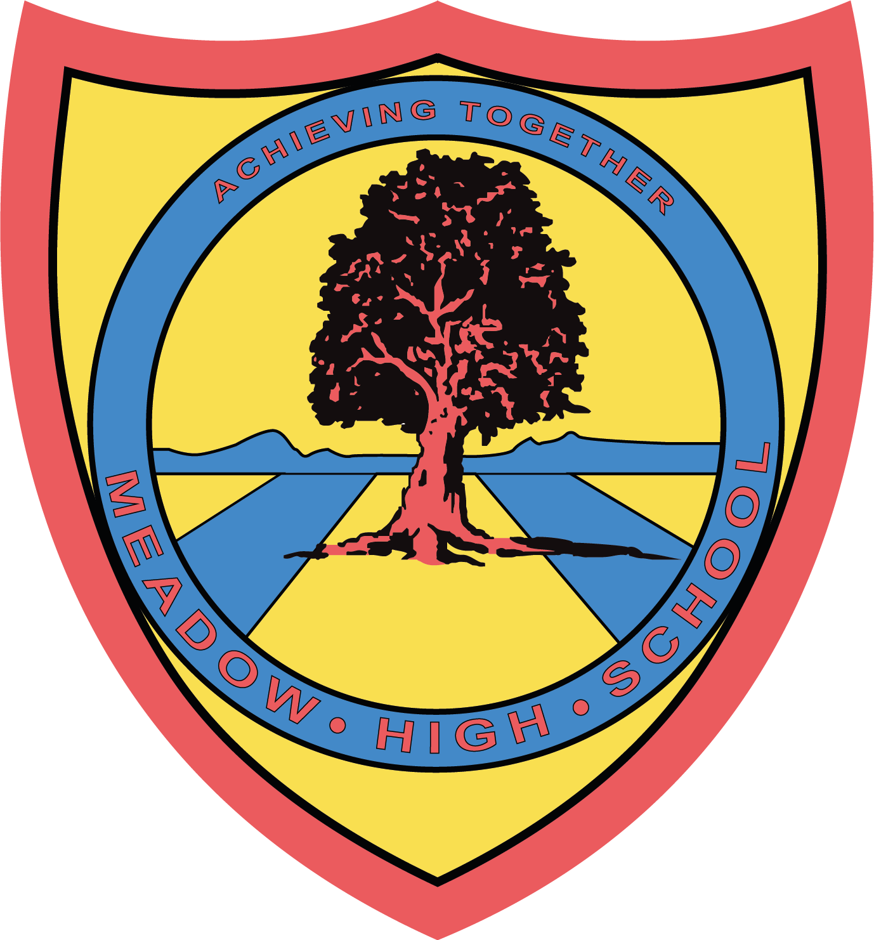

17 March 2025
Dear Parent/Carers,

To support students with their learning in Art we have arranged a trip to the Sculpture Park for all GCSE students on Friday 21st March.

Pupils on the trip should aim to arrive at school promptly by 8:50 if possible. We aim to leave school from the main hall prompt at 9:00 am and return to school for period 6 by 2:10pm.

The visit will heavily support the students Accredited learning/ GCSE qualification

Pupils are Learning: how to use photography and quick sketching skills to research ideas for their project theme. Direct observation and their use of real sources is a requirement of their studies.

Visits to Sculpture Parks are an excellent opportunity to learn about Artists work from around the world and develop imagination in our work to inspire pupils' own art pieces. All the artwork at the Park is for sale, so students will be able to use their mobile phones using the QR code to find out more about them online! If you specifically would not like your child to bring their phone on the trip please notify their Form Tutor or Art teacher by the 19th of March at the latest.

We will travel to Farnham on a minibus, which will be driven by staff who are MIDAS trained. The sculpture park is outside so Students need to bring:
1) A waterproof jacket preferably with hood, (if sunny please provide a sun cap and sunblock)
2) A water bottle/drink
3) A healthy packed lunch with them, but if they are entitled to a free school meal then they will be provided with one.
4) A backpack/Rucksack large enough to carry a standard A4 Sketch book, an Ipad and their lunch
5) A pencil/Pen and rubber
6) A Mobile phone if desired
Any of these additional items that pupils bring on the trip will be documented before departure, whilst the school will take due care and attention to verify items pupils take on the trip return with them, the pupil is responsible for their possessions and the school does not take responsibility for any lost or stolen or damaged equipment.

IPads and SLR Camera’s will be provided for photographic research by the school and pupils are reminded to take due care and attention of any device or equipment they will use.
Please note there is a shallow pond for part of the planned route should water levels be considered higher than usual by the Park Staff or evaluated as a risk by the trip Leader on the day due to heavy rain the original planned blue and green route will be adjusted to the red route without the pond or the trip rescheduled. Students will be reminded of general safety walking around the park especially with regard to water.

We will return to school within normal school hours. This is an educational visit and pupils are expected to attend the trip as part of their learning.

We are looking forward to an exciting and inspiring day out.

Yours Sincerely.
MS Brar & Miss Kepinska
Art Teachers

Article 23:- 'A child with a disability has the right to live a full and decent life with dignity and independence, and to play an active part in the community.'



