Meadow High School
Royal Lane, Hillingdon, Middlesex UB8 3QU

Telephone: (01895) 443310
Email: meadow@meadowhighschool.org
Website: www.meadowhighschool.org

Headteacher: Mrs Jenny Rigby
Deputy Headteacher (Royal Lane): Miss Michelle Taylor
Deputy Headteacher (Northwood Road): Miss Amy Willis
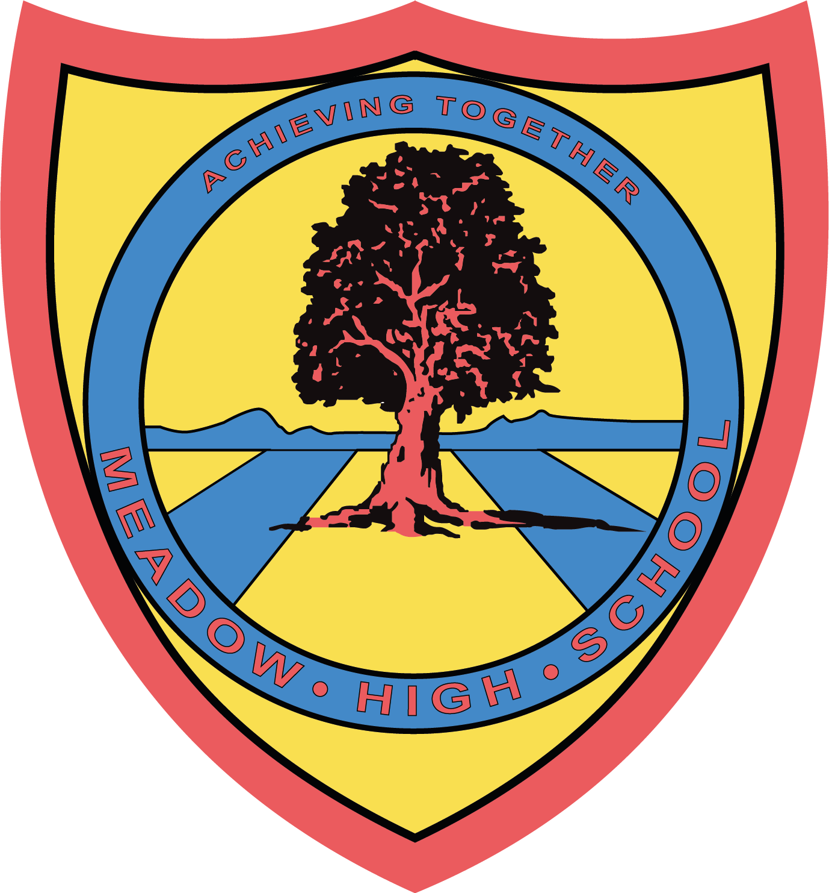

9 December 2024
Dear Parents/Carers,
6VL Trip to Winter Wonderland
As a class, 6VL are going to Winter Wonderland on Thursday 12th December 2024. This trip is an educational opportunity for the class to practise using public transport and social interaction.
We will be leaving at 9,30am and travelling by bus and tube and return to school in time for transport home. We have applied for free travel from London transport, however, if this is not approved, please could students bring their bus passes if they have them.
If students would like to go on a ride, this will be agreed beforehand and students will need to pay for it. The cost of a ride ranges from £7- £12.
Students can bring either a healthy packed lunch or a small amount of money to choose something from one of the stalls in Winter Wonderland. If your child is entitled to a free school lunch, a lunch can be provided, please indicate below, along with sandwich choice, and we will make sure they have a lunch to bring along from school.
Yours sincerely,
Mrs Lazarevic
6th Form Tutor

Article 23:- 'A child with a disability has the right to live a full and decent life with dignity and independence, and to play an active part in the community.'

------------------------------------------------------------------------------------------------------------------------------------------
REPLY SLIP: 12VL Winter Wonderland Trip – Please return to Mrs Lazarevic

Name: ………………………………………………………………………………..

Is entitled to a free school lunch and would like a lunch provided; sandwich choice: tuna mayo ( ) egg mayo ( ) cheese ( )

Will bring in a healthy packed lunch or money for lunch

Parent/Carer signature: ………………………………………………………………

