***Meadow High School***

*Royal Lane, Hillingdon, Middlesex UB8 3QU*

*Telephone: (01895) 443310*

*Email: meadow@meadowhighschool.org*

*Website: www.meadowhighschool.org*

***Headteacher: Mrs Jenny Rigby***

***Deputy Headteacher (Royal Lane): Miss Michelle Taylor***

***Deputy Headteacher (Northwood Road): Miss Amy Willis***

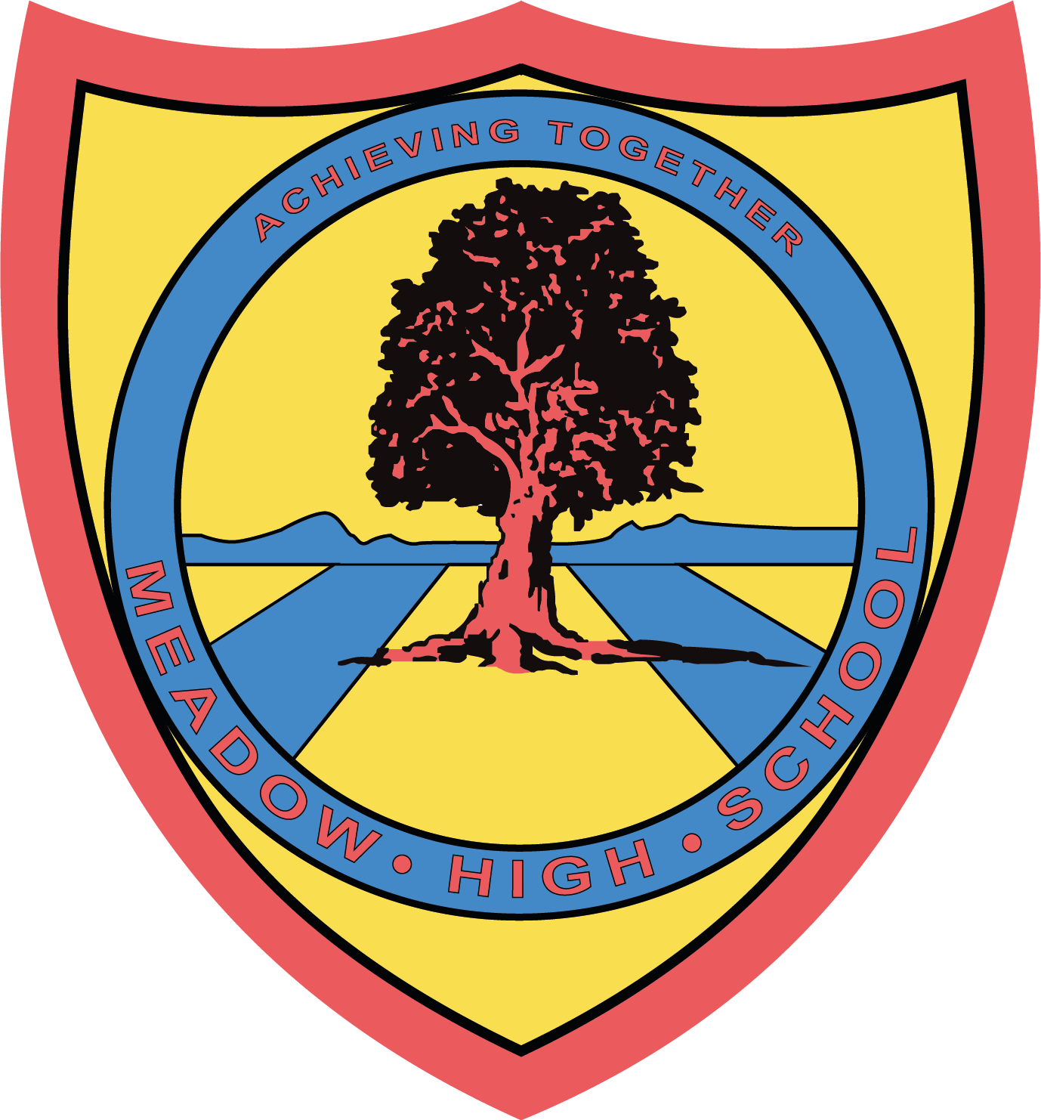

27 January 2025

Dear Parents / Carer

**After School Club; Gymnastics with NMO Sports**

Your child has successfully gained a place at the above club. The club will start from **Wednesday 29 January 2025 for 8 weeks.**

**Payment of £5-per-session needs to be made on ParentPay before the start of each session.** If payment has not been received by lunchtime on the day, parents will be informed that their child will be going home at normal time (15:05). **If participation numbers reduce, the price may have to be reviewed.  Parents will be contacted of this PRIOR to any changes.**

Please note, students will be required to bring their own PE kit to wear.  If for any reason they cannot attend the club that week, please send a message to either myself or the school reception.

Please be aware, in order for this club to run MHS staff are supporting on a voluntary basis, so there is no extra MHS staffing. If your child is unable to access the club or does not take part we will have to withdraw them from the club. This is because the child will be gaining a negative experience from sport, which is something we do not want. We will contact you if this situation occurs.

Lastly, if your child does not wish for a place anymore please let me know as soon as possible.

Please contact me if you have any questions.

Kind regards.

Yours sincerely

**Mr. Anstee**

**PE Faculty Lead and NMO Sports**

***Article 23:- 'A child with a disability has the right to live a full and decent life with dignity and independence, and to play an active part in the community.'***

