Meadow High School
Royal Lane, Hillingdon, Middlesex UB8 3QU

Telephone: (01895) 443310
Email: meadow@meadowhighschool.org
Website: www.meadowhighschool.org

Headteacher: Mrs Jenny Rigby
Deputy Headteacher (Royal Lane): Miss Michelle Taylor
Deputy Headteacher (Northwood Road): Miss Amy Willis
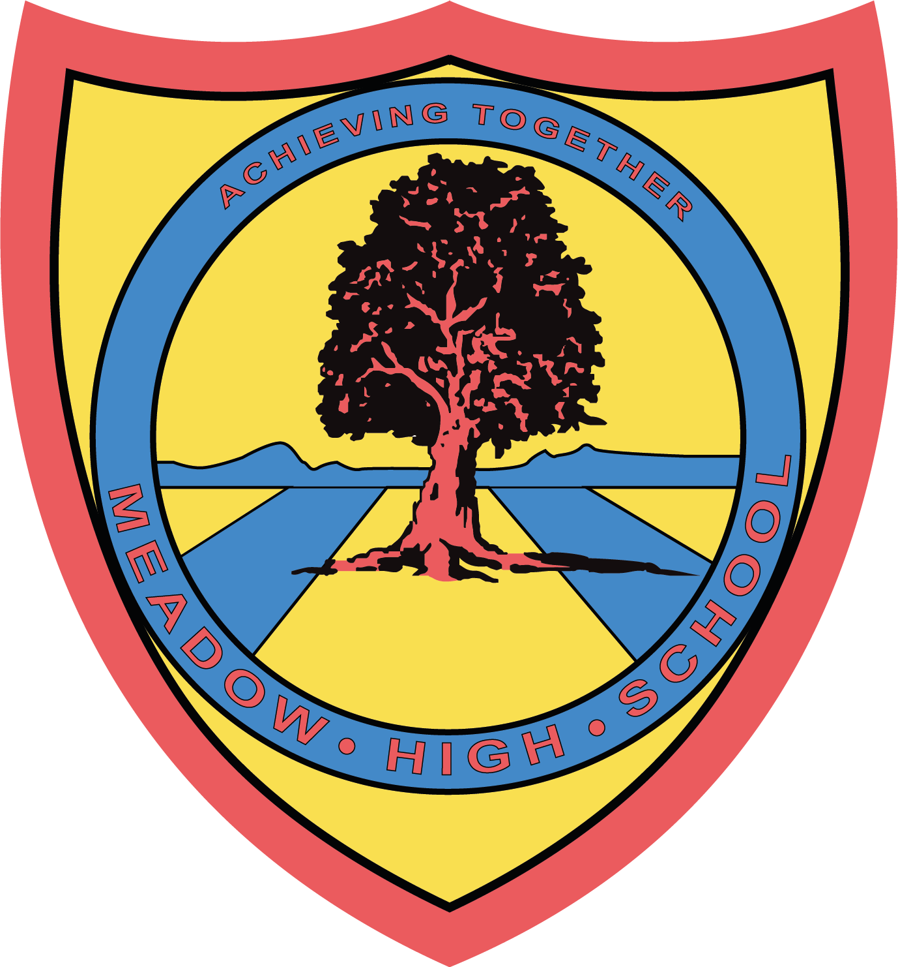

November 2024

Dear Parent/Carers,
11GM Cinema trip
11GM are going to Ealing picture house cinema on Thursday 14th November 2024. This will support pupils’ culture capital alongside their personal development.
We will be watching Kensuke's Kingdom.
There is no cost for this trip and pupils will be provided with snacks for the film. However, we would like to stop off at the shops on the way back to buy something nice for lunch, this is optional and no more than £5 would be required.
We will be leaving at 9.05am and returning at around 12.30pm via coach.
Yours sincerely,

Mrs M Newman
Team Leader

Article 23:- 'A child with a disability has the right to live a full and decent life with dignity and independence, and to play an active part in the community.'



