Meadow High School
Royal Lane, Hillingdon, Middlesex UB8 3QU

Telephone: (01895) 443310
Email: meadow@meadowhighschool.org
Website: www.meadowhighschool.org

Headteacher: Mrs Jenny Rigby
Deputy Headteacher (Royal Lane): Miss Michelle Taylor
Deputy Headteacher (Northwood Road): Miss Amy Willis
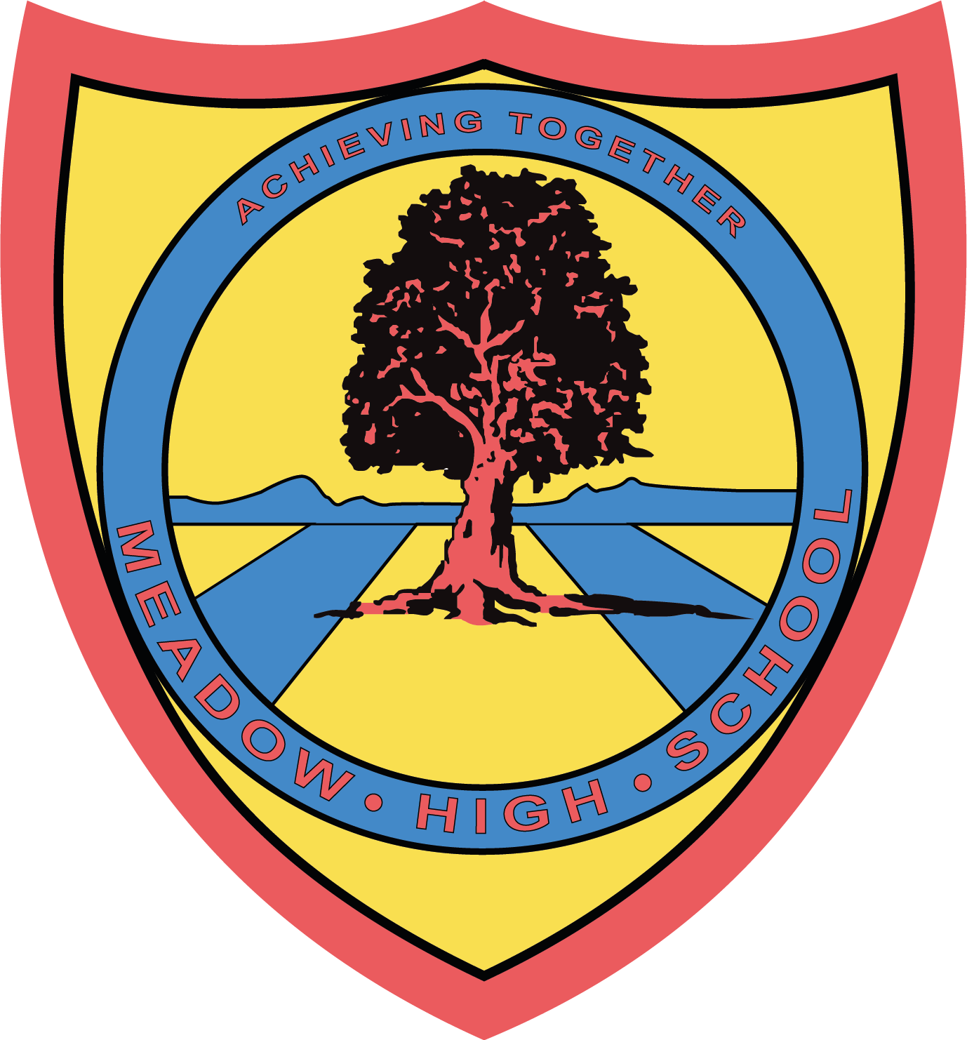

November 2024

Dear Parent/Carer

In Food Technology in Year 9, we will be focusing on cereals and cereal products. This term we will be making:

- Cheesy Pasta
- Spanish Rice
- Fruit Cobbler
- Oatmeal and Raisin Cookies
- Festival project

Students will also taste and evaluate a range of foods. We will also provide a suitable container for the food that they have made to be taken home in.

If you wish for your child to take the products that they prepare, the amount required for all practical lessons will be £7.50 using your Parent Pay account.

If you require any assistance with your Parent Pay account, please contact the school reception for support.

Thank you in advance.

Mrs P. Shukla
Food Technology

Article 23:- 'A child with a disability has the right to live a full and decent life with dignity and independence, and to play an active part in the community.'



