Meadow High School
Royal Lane, Hillingdon, Middlesex UB8 3QU

Telephone: (01895) 443310
Email: meadow@meadowhighschool.org
Website: www.meadowhighschool.org

Headteacher: Mrs Jenny Rigby
Deputy Headteacher (Royal Lane): Miss Michelle Taylor
Deputy Headteacher (Northwood Road): Miss Amy Willis
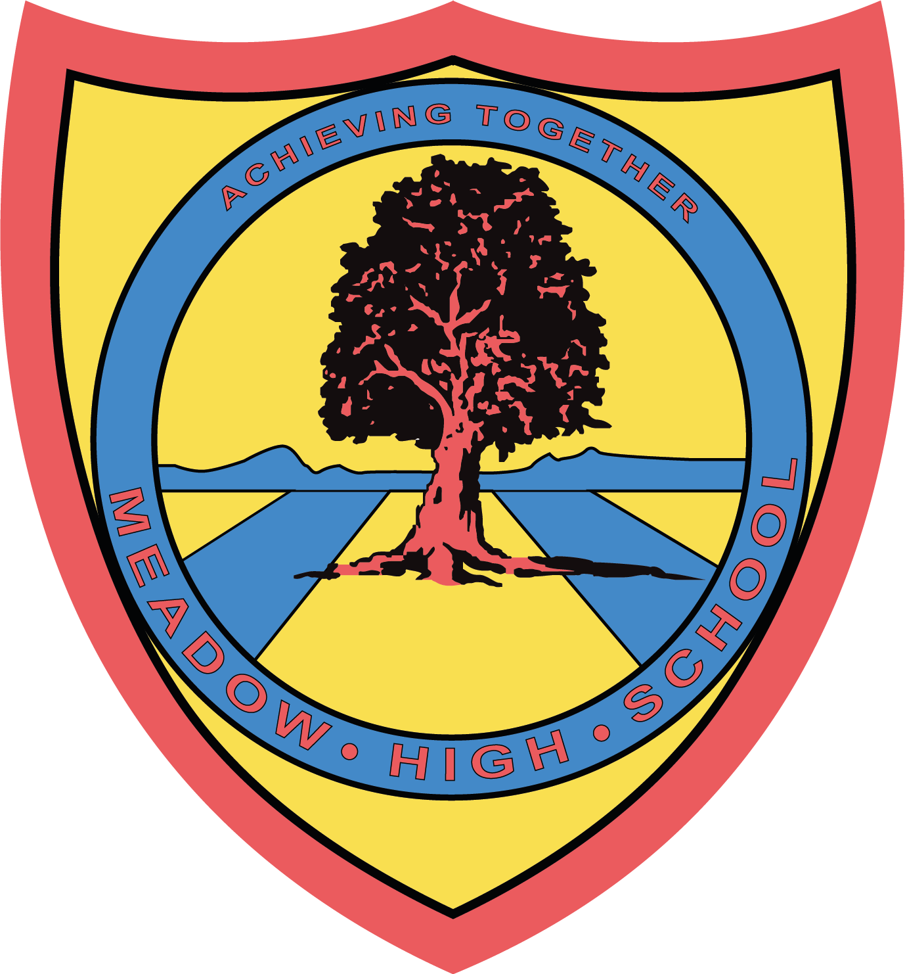

Monday 10th February 2025

Dear Parents / Carers,
Re: Swimming Lessons for Year 8 students
Your child will be having their swimming lessons on a Thursday, Period 4 and 5, instead of PE. The lessons will start on Thursday 27th February 2025.
They will not need their PE kit, but will need their swimming kit. These lessons take place off site and students will be transported there via school mini bus. Their last swimming lesson will be on Thursday the 8th May 2025. After this, they will have PE twice per week again.
They will need to bring:
- Swimming trunks / costume (no bikinis)
- A towel
- Goggles if required
If you have any queries please do not hesitate to contact me at school.
Yours Sincerely,

Miss C Sojka
(Swim Teacher)

Article 23:- 'A child with a disability has the right to live a full and decent life with dignity and independence, and to play an active part in the community.'



