Meadow High School
Royal Lane, Hillingdon, Middlesex UB8 3QU

Telephone: (01895) 443310
Email: meadow@meadowhighschool.org
Website: www.meadowhighschool.org

Headteacher: Mrs Jenny Rigby
Deputy Headteacher PW2/3: Ms Claire Caddell
Deputy Headteacher PW1: Miss Amy Willis
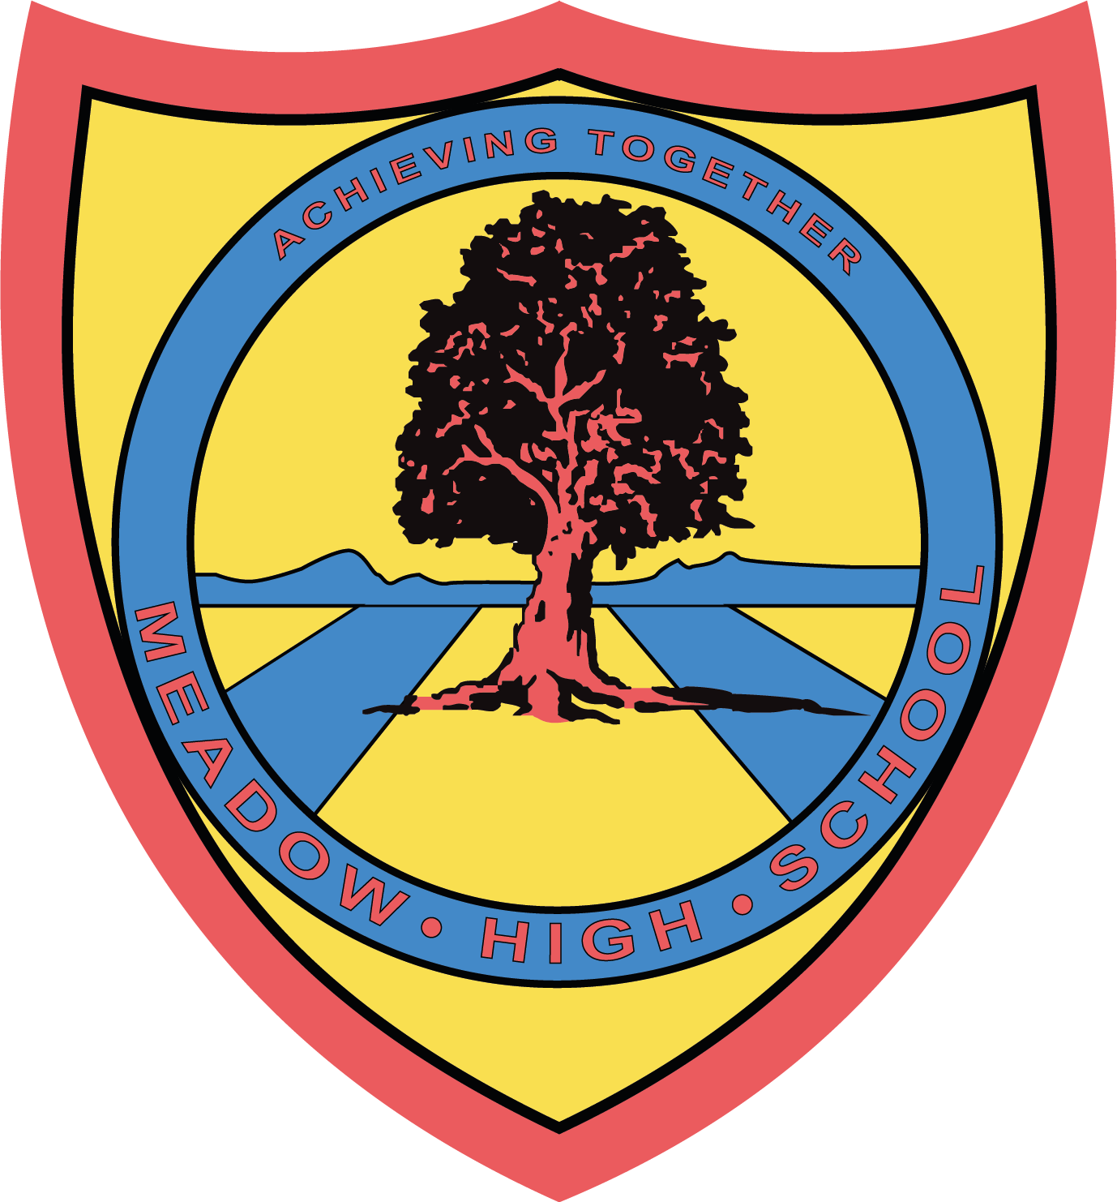

18th July 2024

Dear Parents/Carers,

I am writing to inform you that your child will now be visiting the food company in Stockley on Tuesday 23 July 2024 as part of the Career’s visit to a local employer. This company prepares deli products such as wraps, sandwiches and salads for various supermarkets.

The site address is -
GreenCore Food to Go
366 Stockley, West Drayton
UB7 9BL

Students and school staff members will leave school around 9:45am on the school minibus and will be returning to school by 12:45pm, in time for normal lunch arrangements. During the visit, students will have an opportunity to learn about the background of the company, tour the site, build knowledge of various job roles, meet with professionals and see the production line. Students will get an opportunity to work on the production line as part of the work experience. This trip is free of charge and does not require any contribution.

Should you have any questions, please do not hesitate to email me on: skabhoo@meadowschool.co.uk or call school on 01895 443310 ext. 244

Yours Sincerely,

Mrs Kabhoo
Trip Organiser

Article 23:- 'A child with a disability has the right to live a full and decent life with dignity and independence, and to play an active part in the community.'


