Meadow High School
Royal Lane, Hillingdon, Middlesex UB8 3QU

Telephone: (01895) 443310
Email: meadow@meadowhighschool.org
Website: www.meadowhighschool.org

Headteacher: Mrs Jenny Rigby
Deputy Headteacher (Royal Lane): Miss Michelle Taylor
Deputy Headteacher (Northwood Road): Miss Amy Willis
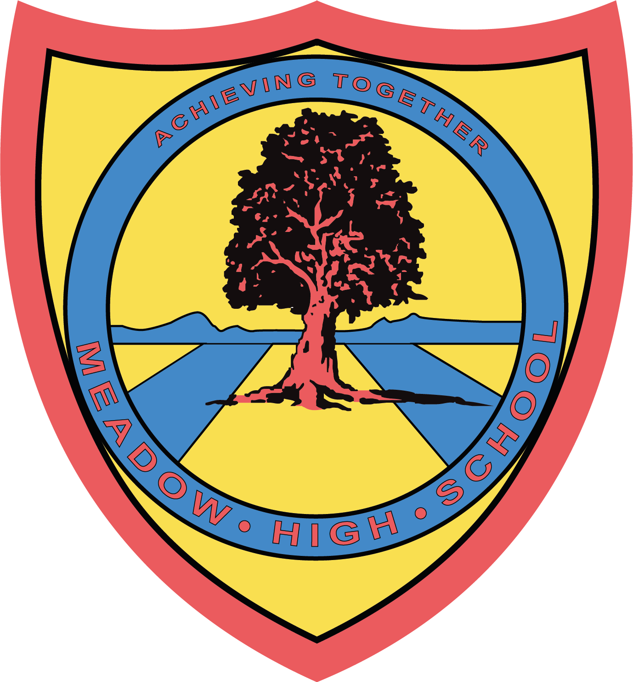

19th November 2024

Dear Parents/Carers,

At Meadow High School, we are committed to fostering an inclusive and supportive environment where all students can thrive and celebrate their unique identities. Following positive feedback from our students, we are excited to invite your child to participate in a new initiative aimed at celebrating the rich diversity within our school community: our Cultural Connections sessions.
These groups are designed to provide students with a safe, welcoming space to explore and discuss their cultural heritage, share experiences, and build a sense of connection with peers from similar or diverse backgrounds. The aim is to help students feel proud of their identities, exchange perspectives, and engage in meaningful conversations that promote understanding and respect for all cultures.
Each group will be led by a trained facilitator who will guide discussions and activities centred around cultural appreciation, identity, and personal experiences. The session will take place Friday 22nd November - 11.30-12.30. We are excited to see how students will benefit from this collaborative environment.
We believe that participation in these groups will not only enrich your child’s sense of self but also contribute to a greater sense of unity and respect throughout our school community. We encourage students from all cultural backgrounds to attend, as we hope these discussions will foster mutual understanding and respect among all.
If you have any questions or would like more information, please don’t hesitate to contact us.
Thank you for your continued support in creating an inclusive, respectful, and empowering school environment for all students.
Kind Regards,

Maxine Newman & Claire Sjoka
Anti Racism Coordinators

Article 23:- 'A child with a disability has the right to live a full and decent life with dignity and independence, and to play an active part in the community.'
