Meadow High School
Royal Lane, Hillingdon, Middlesex UB8 3QU

Telephone: (01895) 443310
Email: meadow@meadowhighschool.org
Website: www.meadowhighschool.org

Headteacher: Mrs Jenny Rigby
Deputy Headteacher (Royal Lane): Miss Michelle Taylor
Deputy Headteacher (Northwood Road): Miss Amy Willis
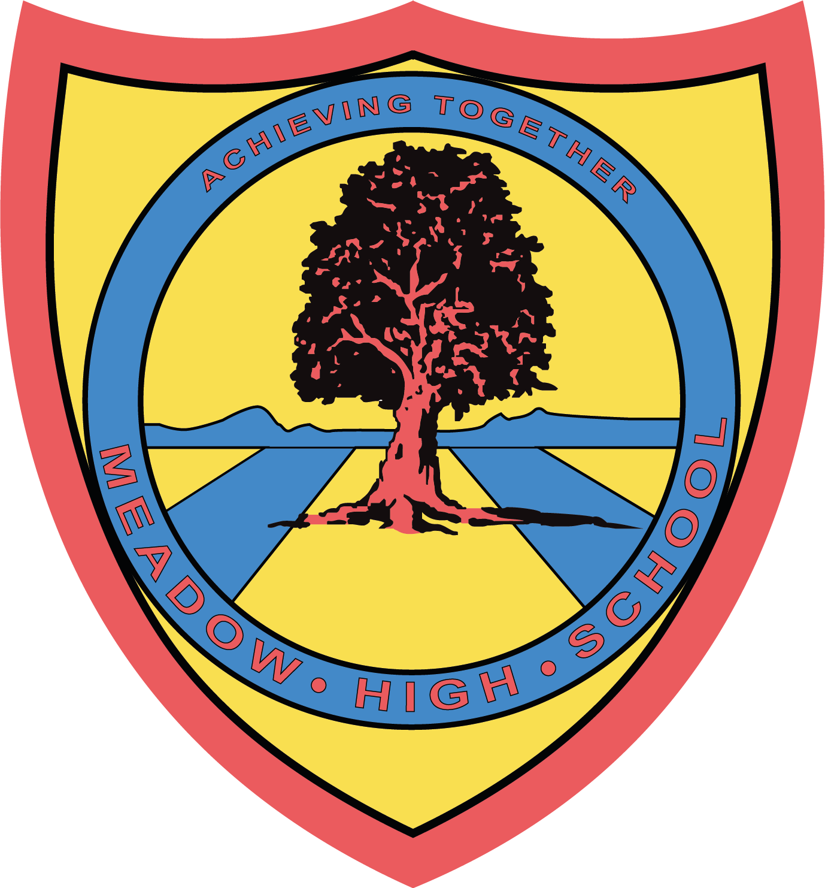

18th March 2025

Dear Parents/Carers,

As part of PE lessons, pupils in Class YA will be having swimming lessons starting on 28th April 2025 until 21st July 2025.

Pupils will travel via minibus to Windsor Leisure Centre and be taught by qualified swim instructors. Members of staff from the class team will also be in the water to support.

Swimming will occur each Monday. Pupils will require suitable swimming shorts, a towel and any other personal preferences when swimming such as googles. I also suggest sending in an extra snack and drink as swimming can make you hungry.
Yours sincerely,

Faye Bonnar
Assistant Head Teacher Pathway 1

Article 23:- 'A child with a disability has the right to live a full and decent life with dignity and independence, and to play an active part in the community.'



