***Meadow High School***

*Royal Lane, Hillingdon, Middlesex UB8 3QU*

*Telephone: (01895) 443310*

*Email: meadow@meadowhighschool.org*

*Website: www.meadowhighschool.org*

***Headteacher: Mrs Jenny Rigby***

***Deputy Headteacher (Royal Lane): Miss Michelle Taylor***

***Deputy Headteacher (Northwood Road): Miss Amy Willis***

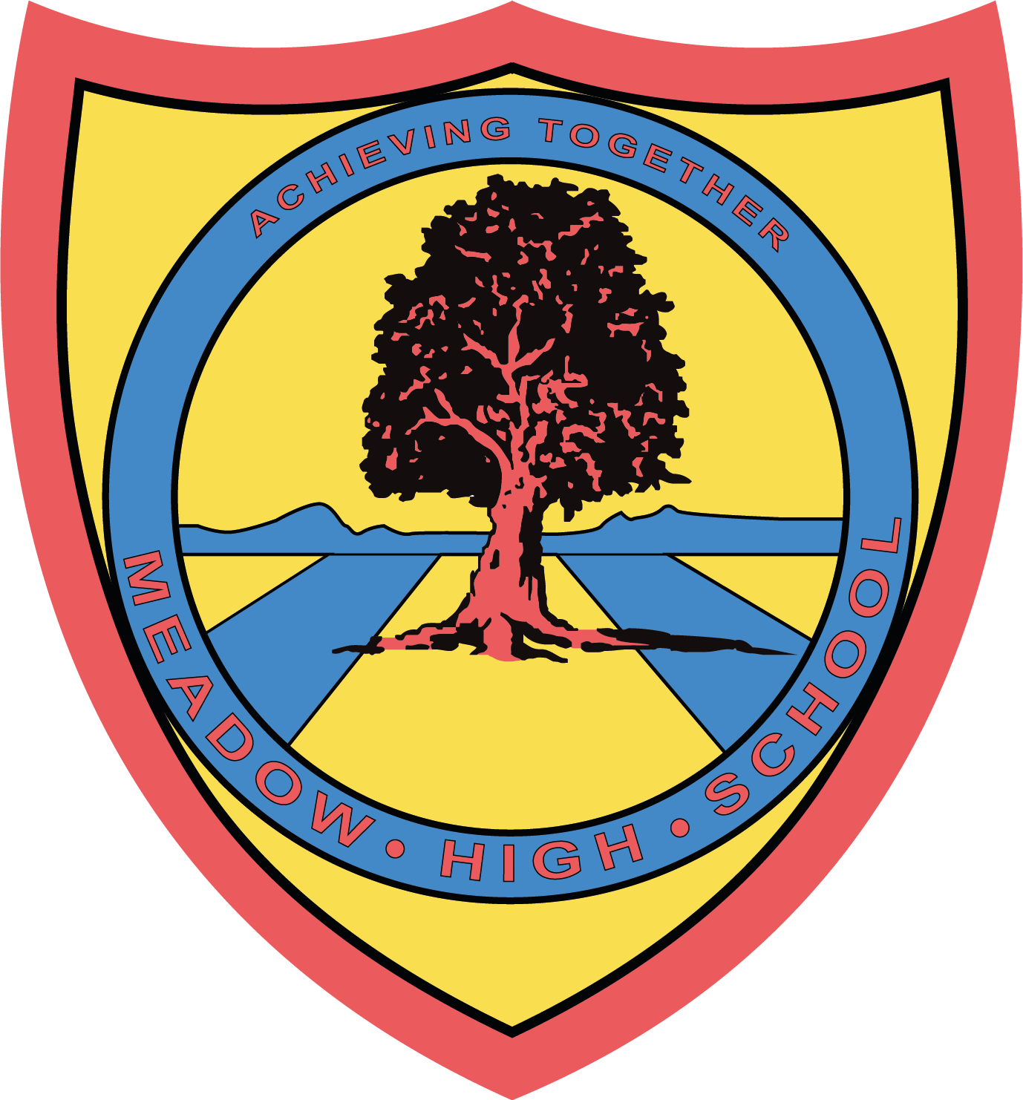

September 2024

Dear Parent/Carer,

For their Unit Award in Food Technology pupils will be focusing on 4-6 units of work, with a range of different cooked products. Pupils will be taking part in some theory lessons to further their understanding of Health and Safety in the kitchen, and practical lessons where they will be building up their confidence towards everyday cooking.

Pupils will also take part in sensory evaluations of various foods. If you wish for your child to take home the products that he/she prepares, the amount required for the practical and taste-testing lessons will be **£10.00** for each Term, using your Parent Pay account.

If you require assistance with your Parent Pay account, please contact the school reception for support.

Thank you in advance.

**Mrs P. Shukla**

**Food Technology Department**

***Article 23:- 'A child with a disability has the right to live a full and decent life with dignity and independence, and to play an active part in the community.'***

