Meadow High School
Royal Lane, Hillingdon, Middlesex UB8 3QU

Telephone: (01895) 443310
Email: meadow@meadowhighschool.org
Website: www.meadowhighschool.org

Headteacher: Mrs Jenny Rigby
Deputy Headteacher (Royal Lane): Miss Michelle Taylor
Deputy Headteacher (Northwood Road): Miss Amy Willis
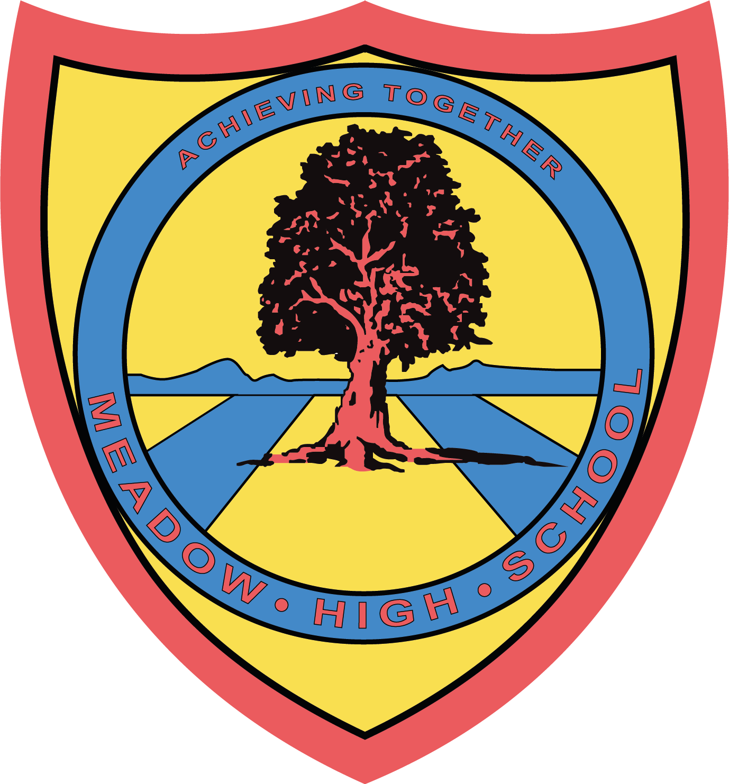

Monday 31st March 2025

Dear Parents / Carers,
Re: Swimming Lessons for Year 7 students
Your child will be having their swimming lessons every Tuesday period 2 and 3, instead of PE, starting on Tuesday 22nd April 2025.
These lessons are conducted off site and students will be taken there via school mini bus.
Swimming lessons will be taken by a teacher from Meadow who is qualified to teach swimming lessons. They will run until Tuesday 20th May 2025
They will need to bring:
- Swimming trunks / costume (no bikinis)
- A towel
- Goggles if required
If you have any queries please do not hesitate to contact me at school.
Yours Sincerely,
Ms C Sojka
(Swim Teacher)

Article 23:- 'A child with a disability has the right to live a full and decent life with dignity and independence, and to play an active part in the community.'



