Meadow High School
Royal Lane, Hillingdon, Middlesex UB8 3QU

Telephone: (01895) 443310
Email: meadow@meadowhighschool.org
Website: www.meadowhighschool.org

Headteacher: Mrs Jenny Rigby
Deputy Headteacher (Royal Lane): Miss Michelle Taylor
Deputy Headteacher (Northwood Road): Miss Amy Willis
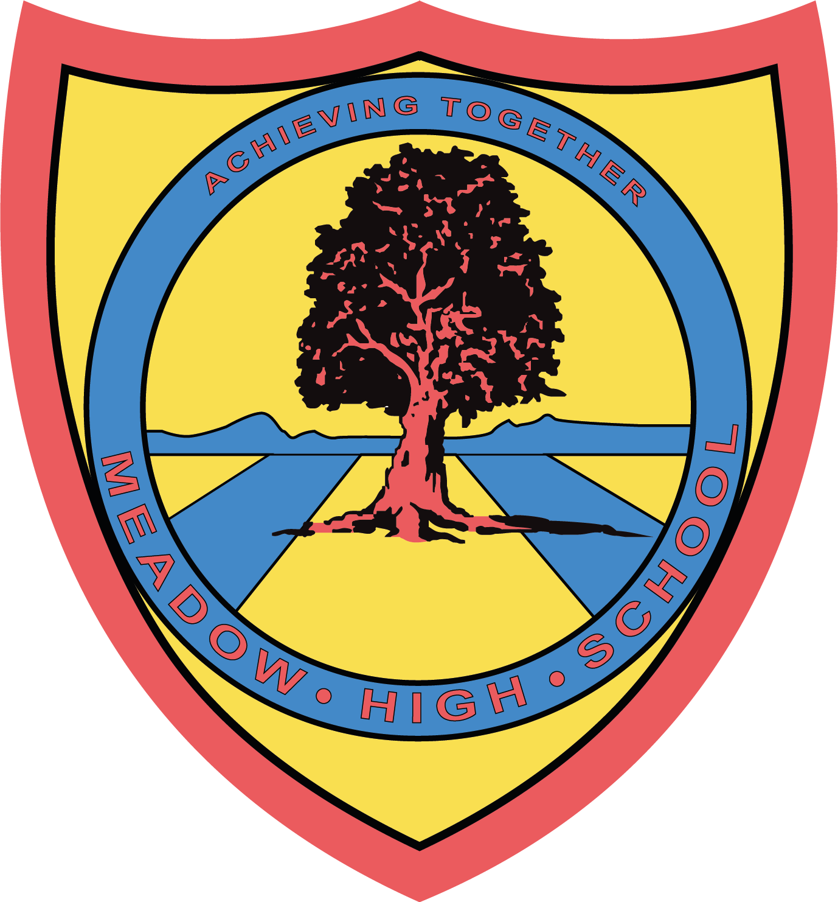

20th March 2025

Dear Parents/ Carers,

Cancellation of Gymnastics After-School Club

Apologies, but due to us not having enough volunteering staff, we are no longer able to offer Gymnastics After School Club on a Wednesday.

If you are owed money, a refund will be processed as soon as possible.

If you owe money, we will be in contact soon.

Apologies for the inconvenience. Pupils will be leaving school at normal time 15:05 on Wednesday's.

Yours sincerely,

Mr B Anstee
PE Faculty Lead

Article 23:- 'A child with a disability has the right to live a full and decent life with dignity and independence, and to play an active part in the community.'



