Meadow High School
Royal Lane, Hillingdon, Middlesex UB8 3QU

Telephone: (01895) 443310
Email: meadow@meadowhighschool.org
Website: www.meadowhighschool.org

Headteacher: Mrs Jenny Rigby
Deputy Headteacher: Ms Claire Caddell

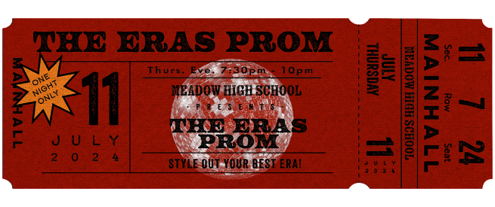

Dear Parents/Guardians, 19th June 2024
Re: Year 11 & 6th Form ERAS PROM – Thursday 11th July 2024
To celebrate the achievements of our Year 11 and 6th Form students, we will be holding our school Prom on Thursday 11th July 2024 between 7:30pm and 10:00pm in the school hall. Ticket price £10.
The theme this year is Eras, a retro-chic celebration of fashion through time. This reflects the work we have been doing with our students on sustainable fashion and finding your own style – at Meadow High School we believe that celebrating our individuality and expressing who we are is what it’s all about! Wear what makes you feel amazing!

Prom Shop: Our Prom Shop will be open from Mon. 24th June. Students can bring in an item to swap for something else; if they don’t have anything to swap, come along anyway, we will be happy to help!
Dee’s Salon: Thanks to the kindness of Ms. Lee and her team, we will be open for appointments. If your child would like support with hair and/or nails to help them feel fabulous on the night please tick the box on the slip below and we will contact you to arrange a suitable time – first come, first served.

Prom tickets are on sale NOW until Monday 1st July ’24. The ticket price includes a visit to Miss Barratt’s famous mocktail bar, Mr. M. ‘spinning the discs’ as well as a special buffet of Asian-style food, and entertainment from the incredible magician Angus Baskerville, a rising star heading to the Edinburgh Fringe Festival this summer. Angus will be amazing us with his close up magic skills – I can’t wait!

There will be plenty of opportunities to take photos on the night. If you do not want your child to be in any photographs with friends please contact your child’s Form Tutor.
We hope very much that all students will attend as the evening is a celebration of their shared experiences at Meadow High School and the journey they have all been on together.
Yours faithfully,
Anne Sugden & Jennie Tudor
On behalf of the Prom Committee
-------------------------------------------------------------------------------------------------------------------------------------------------------------------------------------------------------------
Reply Slip: Year 11, 12, 13 & 14 Summer Prom 2024 – Thursday 11th July 2024
I give my permission for my child …………………………………………………………………... to attend the above event.

( ) I confirm that I have paid for a ticket using ParentPay.
( ) My child will be collected at 10:00pm by …..…………………………….………….Tel. no………………..…………….....
( ) I give my permission for my child to make their own way home at the end of the night.
( ) My child would like an appointment at the Dee’s Salon. Hair / nails. (please circle)
Signed……………………………………………….……………... Date………………………………….. Class: ………..…….
PRINT NAME: …………………………………………………………

This year at Prom we are providing a special buffet.

The food will be an Asian selection of some all-time favourites. You will be able to pick and choose what you would like to try.

The idea is to have the opportunity to try something different!

Vegetable Samosas Vegetable Spring Rolls Vegetable Biryani

Chicken Tikka Wraps Vegetable Tikka Wraps (Aloo Tikki) Vegetable Pakkora (gf)

PLEASE NOTE: If you have any specific dietary requirements, please speak to your Form Tutor by 26th June ’24 as we will be confirming details with our caterer on the 27th June ’24.

Article 23:- 'A child with a disability has the right to live a full and decent life with dignity and independence, and to play an active part in the community.'

