Meadow High School
Royal Lane, Hillingdon, Middlesex UB8 3QU

Telephone: (01895) 443310
Email: meadow@meadowhighschool.org
Website: www.meadowhighschool.org

Headteacher: Mrs Jenny Rigby
Deputy Headteacher PW2/3: Ms Claire Caddell
Deputy Headteacher PW1: Miss Amy Willis
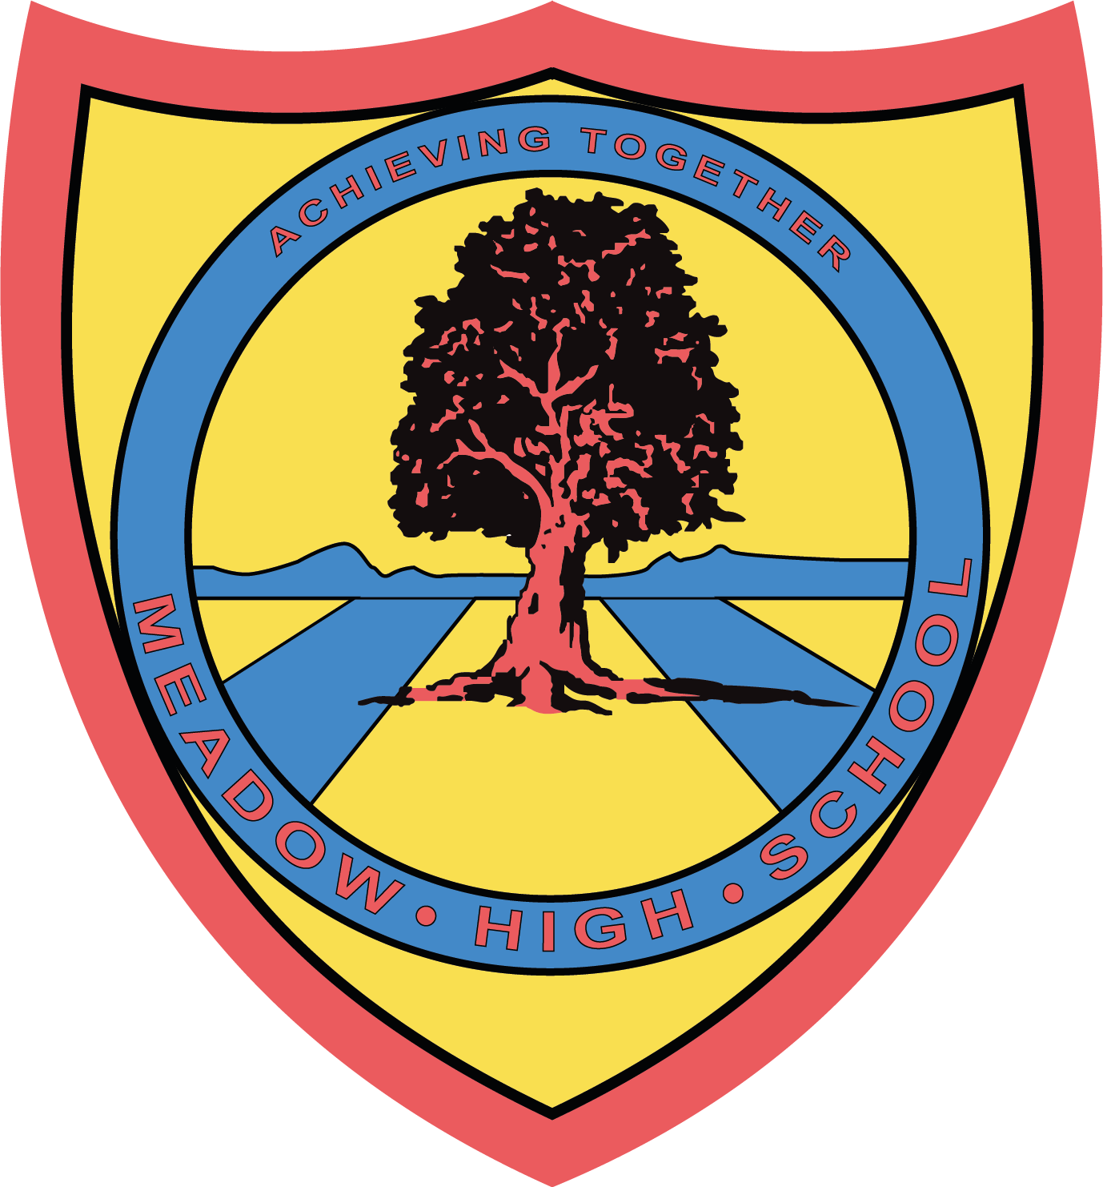

14th June 2024

Dear Parents/Carers,

To support your child with their life skills learning, we have arranged a visit to Pizza Hut (Hayes) on Monday 8th July 2024.

We will be leaving school at 11.30am and returning to school at 2.30pm in time for normal transport home. We will be traveling by minibus, which will be driven by MIDAS (qualified) trained drivers, first aiders will also accompany us.

Students are required to wear school uniform. Please ensure that your young person has sensible walking shoes and a coat with them.

We hope that your young person will be able to take part in this trip, as it is designed to support the learning that takes place in the lesson. Please complete the attached slip and return it as soon as possible.

If you have any enquiries please feel free to contact your child’s form tutor.

Yours sincerely,

Jennie Evans
KS5 Form Tutor

Article 23:- 'A child with a disability has the right to live a full and decent life with dignity and independence, and to play an active part in the community.'

…….……………………………………………………………………………………………………………….
Reply-Slip: Pizza Hut Trip – 8th July 2024 - please give to your child’s form tutor.

I give my permission for ……………………………………………..……….…to take part in the above trip.

Signed (Parent/ Carer): …………………………………………………….. Date ……………….
Emergency contact number: ………………………………………………………

