Meadow High School
Royal Lane, Hillingdon, Middlesex UB8 3QU

Telephone: (01895) 443310
Email: meadow@meadowhighschool.org
Website: www.meadowhighschool.org

Headteacher: Mrs Jenny Rigby
Deputy Headteacher (Royal Lane): Miss Michelle Taylor
Deputy Headteacher (Northwood Road): Miss Amy Willis
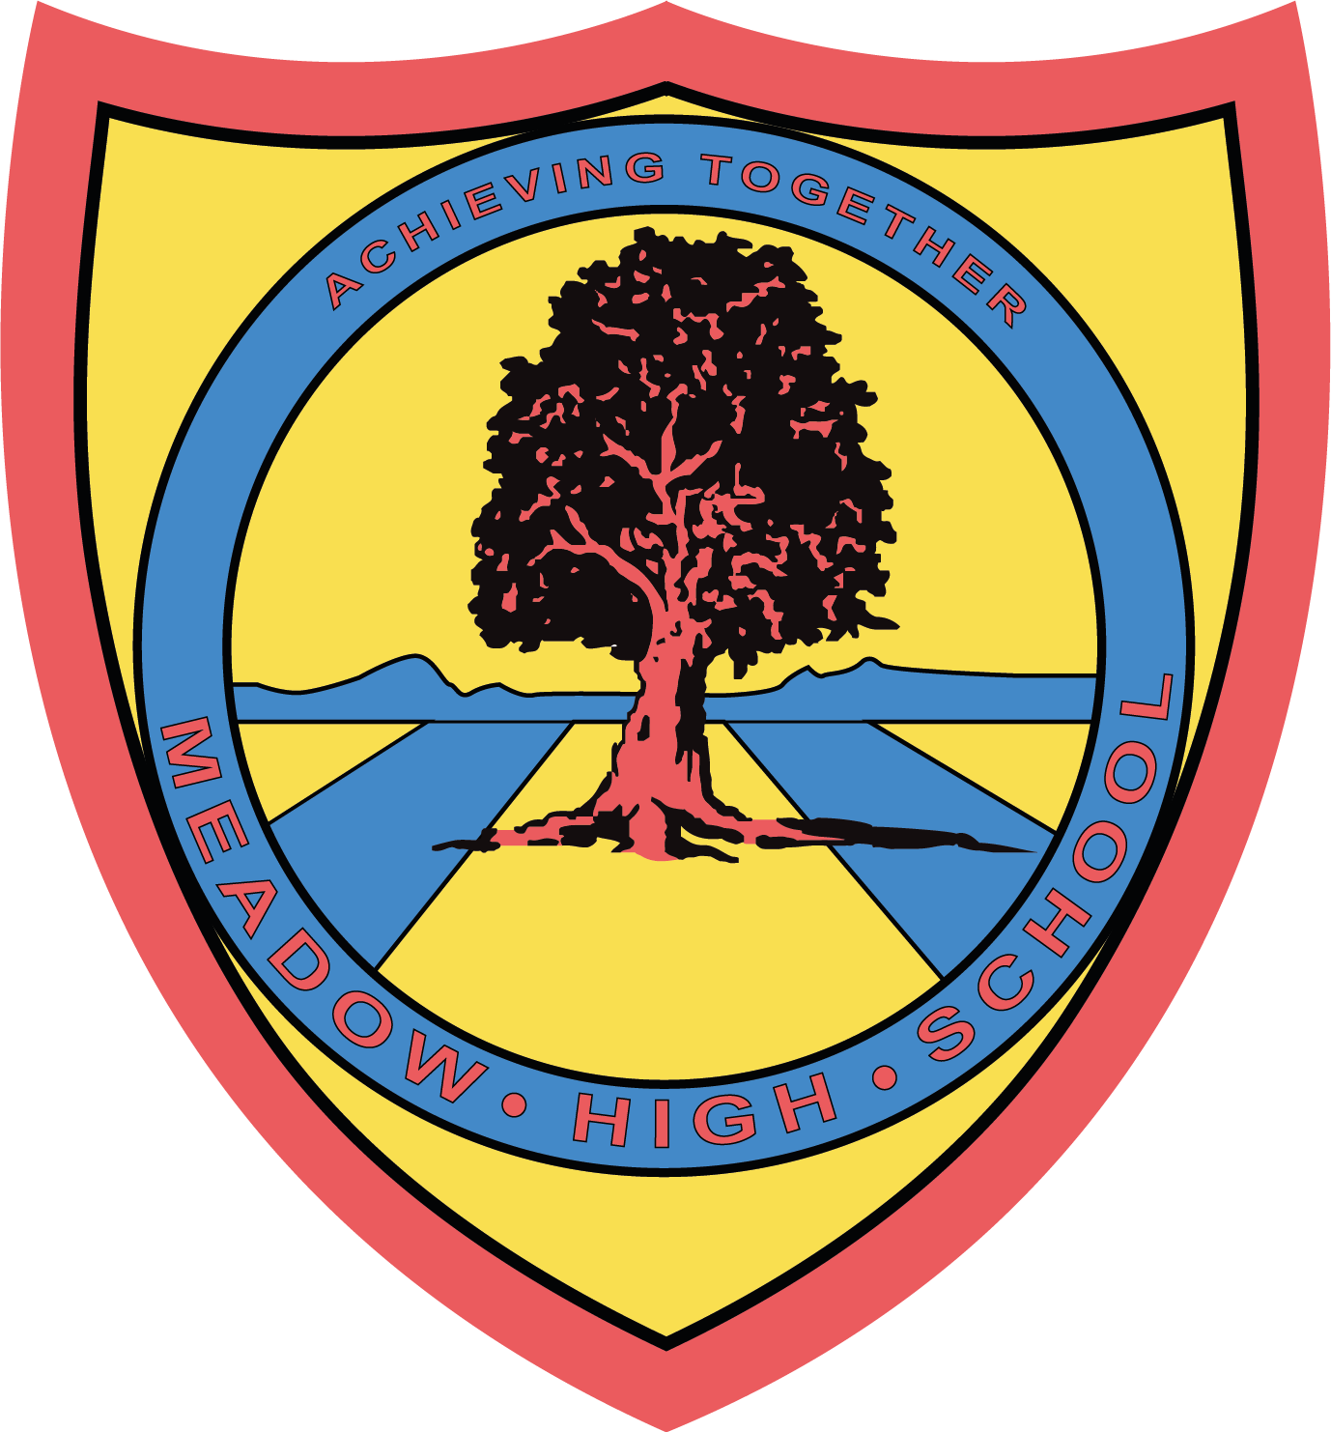



Wear Red Day
Dear Parents/Carers

On Friday 18th October 2024, as a School we are going to take part in an event organised by Show Racism the Red Card (SRtRC), called “Wear Red Day”.

SRtRC is the UK’s largest anti-racism educational charity, and you can find out some more information about the organisation at https://www.theredcard.org

At School, pupils and staff are being asked to wear something red in support of being a proud anti-racist, in order to dismantle racism in society . It can be wearing lots of red clothes, or as simple as wearing red socks.

In the run up to Wear Red Day, we will be talking to the pupils about the charity and why it was first introduced and how they can challenge racism.

If you would like to donate £1 to the organisation using the following method:
By Text:
Text ‘RED’ to 70470 to give£1, ‘RED5’ to give £5, ‘RED10’to give £10 etc. (texts cost gift value + std msg rate)
Yours sincerely,
M Newman & C Sojka
Article 23:- 'A child with a disability has the right to live a full and decent life with dignity and independence, and to play an active part in the community.'



