Meadow High School
Royal Lane, Hillingdon, Middlesex UB8 3QU

Telephone: (01895) 443310
Email: meadow@meadowhighschool.org
Website: www.meadowhighschool.org

Headteacher: Mrs Jenny Rigby
Deputy Headteacher PW2/3: Ms Claire Caddell
Deputy Headteacher PW1: Miss Amy Willis
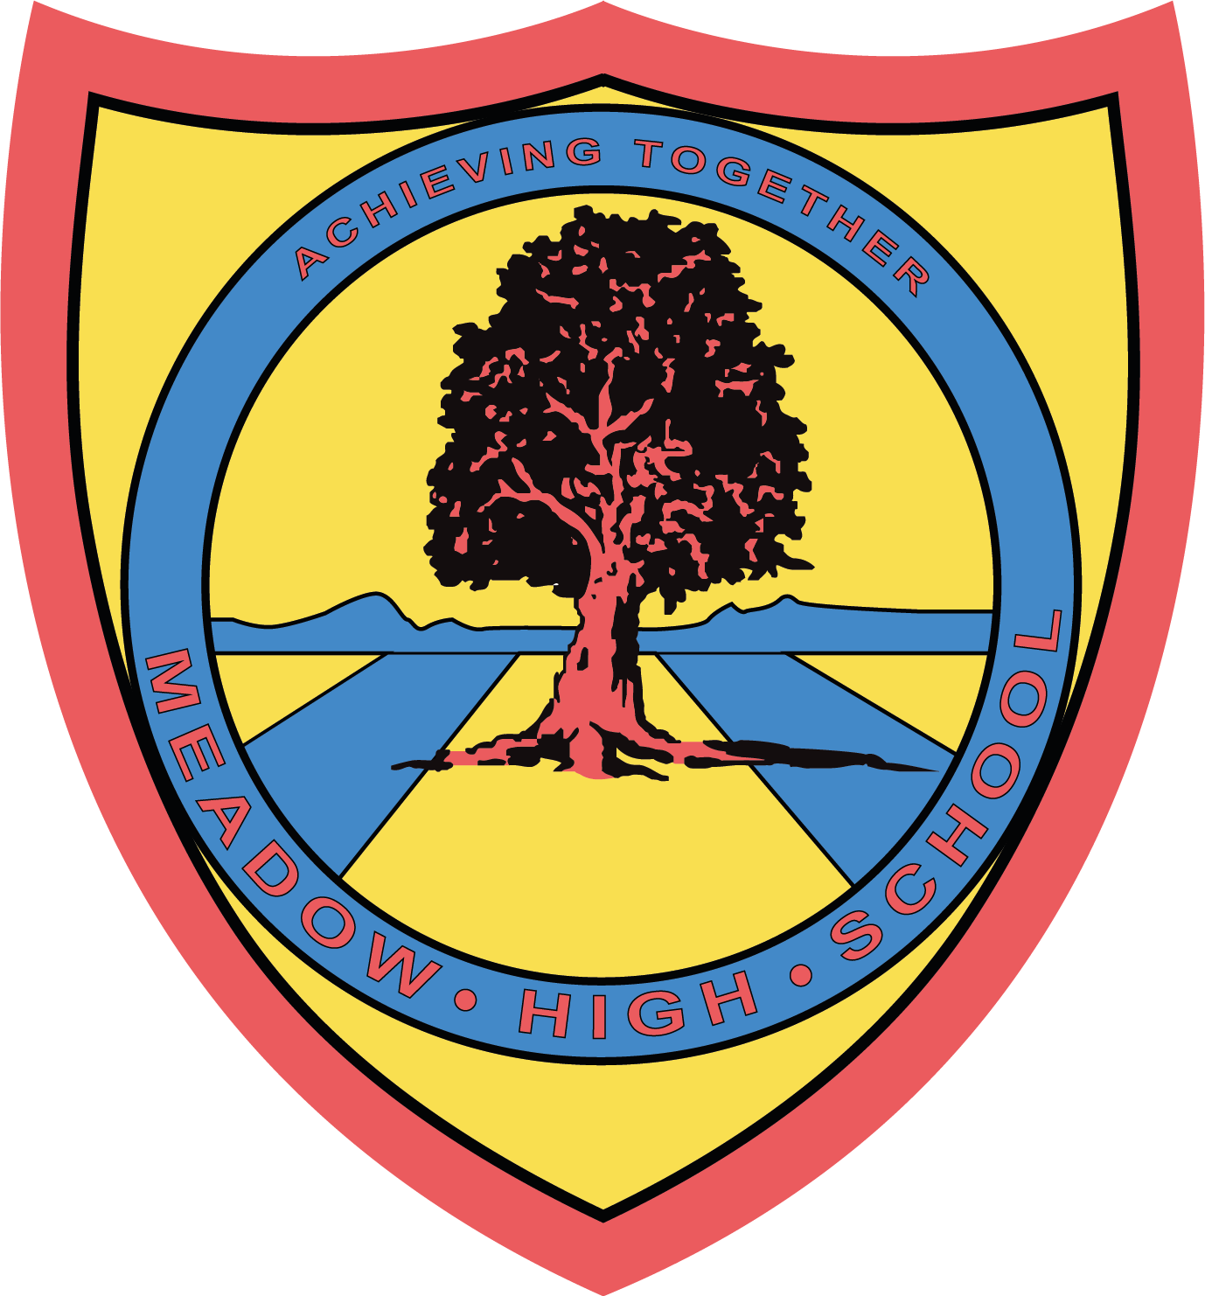

7th May 2024

Dear Parents/Carers,

I am writing to inform you that your child will be visiting the food company in Stockley on 23 May 2024 as part of the Career’s visit to a local employer. This company prepares deli products such as wraps, sandwiches and salads for various supermarkets.

The site address is -
GreenCore Food to Go
366 Stockley, West Drayton
UB7 9BL

Students and school staff members will leave school around 9:45 am on the school minibus and will be returning to school by 12:45pm. During the visit, students will have an opportunity to learn about the background of the company, tour the site, build knowledge of various job roles, meet with professionals and see the production line. Students might get an opportunity to prepare their own sandwich as part of the work experience. This trip is free of charge and doesn’t require any contribution.

Should you have any questions, please do not hesitate to email me on:
skabhoo@meadowschool.co.uk or call school on 01895 443310 ext. 244

Yours Sincerely,

Mrs Kabhoo
Trip organiser

Article 23:- 'A child with a disability has the right to live a full and decent life with dignity and independence, and to play an active part in the community.'


___________________________________________________________________________________
GreenCore Food To Go - Photo permission slip

Please sign and return this slip if you give permission for the photo to be taken by the hosting organisation for their internal and external publication purposes.

Child Name :
Class:
Parent Name:
Parent Signature:
Date:

