Meadow High School
Royal Lane, Hillingdon, Middlesex UB8 3QU

Telephone: (01895) 443310
Email: meadow@meadowhighschool.org
Website: www.meadowhighschool.org

Headteacher: Mrs Jenny Rigby
Deputy Headteacher (Royal Lane): Miss Michelle Taylor
Deputy Headteacher (Northwood Road): Miss Amy Willis
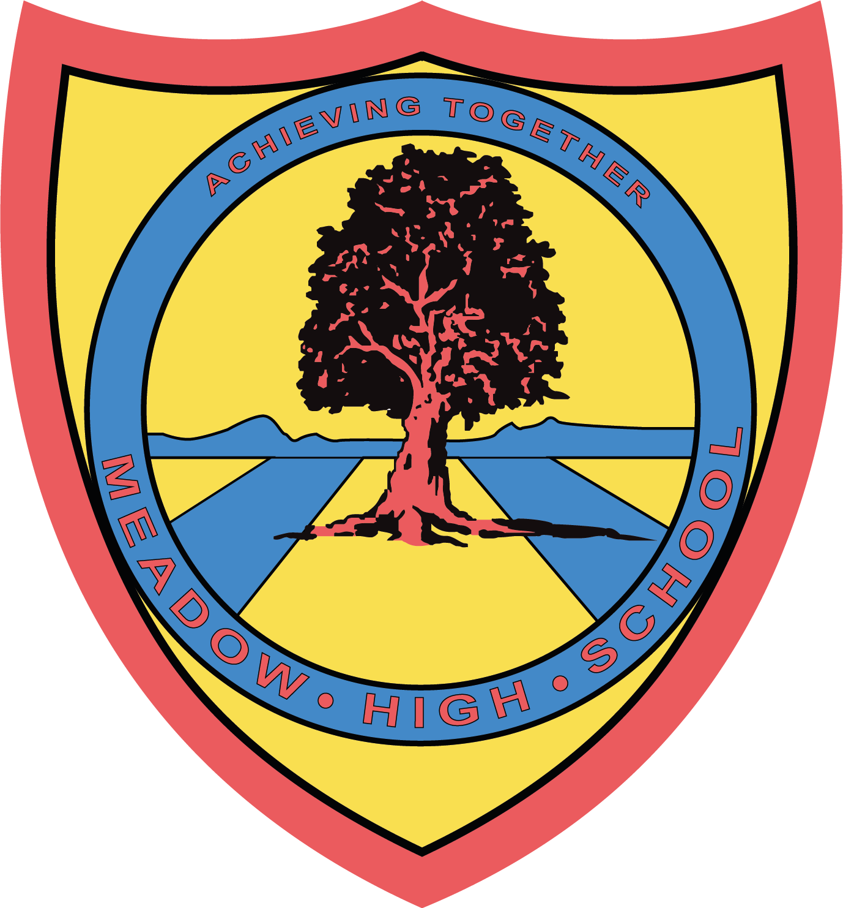

25th November 2024

Dear Parents/ Careers,

U16’s Football Tournament

Your child has been selected to attend the Football Event on Wednesday 27th November 2024.

The event will be taking place between 09:30 – 12:40 so no extra travel arrangements need to be made. Pupils will also be back for normal lunch arrangements.

On the day, your child should come into school in their PE kit with shin pads.

If you have any questions just let me know.

Kind regards,

Mr. Anstee
PE Faculty Lead

Article 23:- 'A child with a disability has the right to live a full and decent life with dignity and independence, and to play an active part in the community.'



