Meadow High School
Royal Lane, Hillingdon, Middlesex UB8 3QU

Telephone: (01895) 443310
Email: meadow@meadowhighschool.org
Website: www.meadowhighschool.org

Headteacher: Mrs Jenny Rigby
Deputy Headteacher PW2/3: Ms Claire Caddell
Deputy Headteacher PW1: Miss Amy Willis
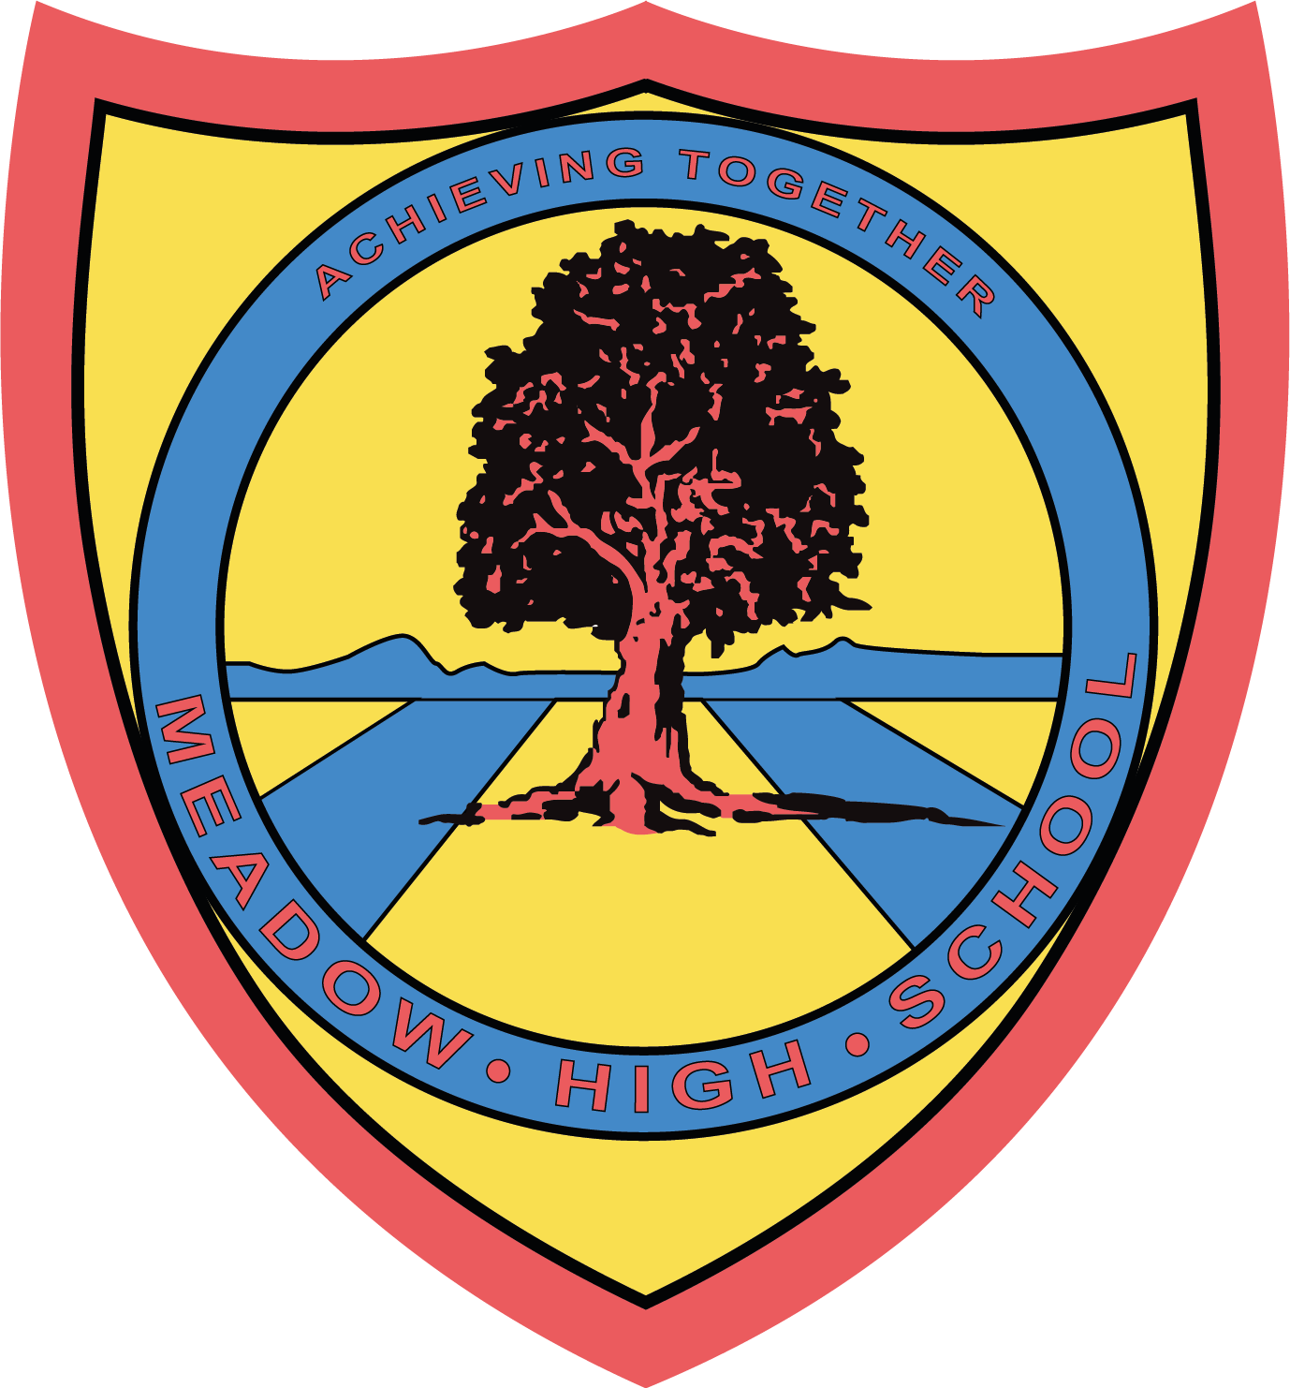

7 June 2024

Dear Parents/Carers,

GCSE Art Exhibition

You are warmly invited to the exhibition of your child's work on Thursday 13th June 2024 from 3:45pm - 4:30pm. Pupils are welcome to attend with you.

Please return the reply-slip by Wednesday 12th June to indicate if you will be attending and who will be with you. There is a maximum of 6 people per family.

Regards,

Miss Kepinska
Arts Faculty Leader

Article 23:- 'A child with a disability has the right to live a full and decent life with dignity and independence, and to play an active part in the community.'

____________________________________________________________________________RSVP : GCSE Art Exhibition

Will you be attending: Yes / No

Please indicate the names of people attending (maximum of 6 visitors per child)

Name 1_______________________________________

Name 2______________________________________

Name 3_______________________________________

Name 4 _______________________________________

Name 5 _______________________________________

Name 6 _______________________________________

