Meadow High School
Royal Lane, Hillingdon, Middlesex UB8 3QU

Telephone: (01895) 443310
Email: meadow@meadowhighschool.org
Website: www.meadowhighschool.org

Headteacher: Mrs Jenny Rigby
Deputy Headteacher PW2/3: Ms Claire Caddell
Deputy Headteacher PW1: Miss Amy Willis
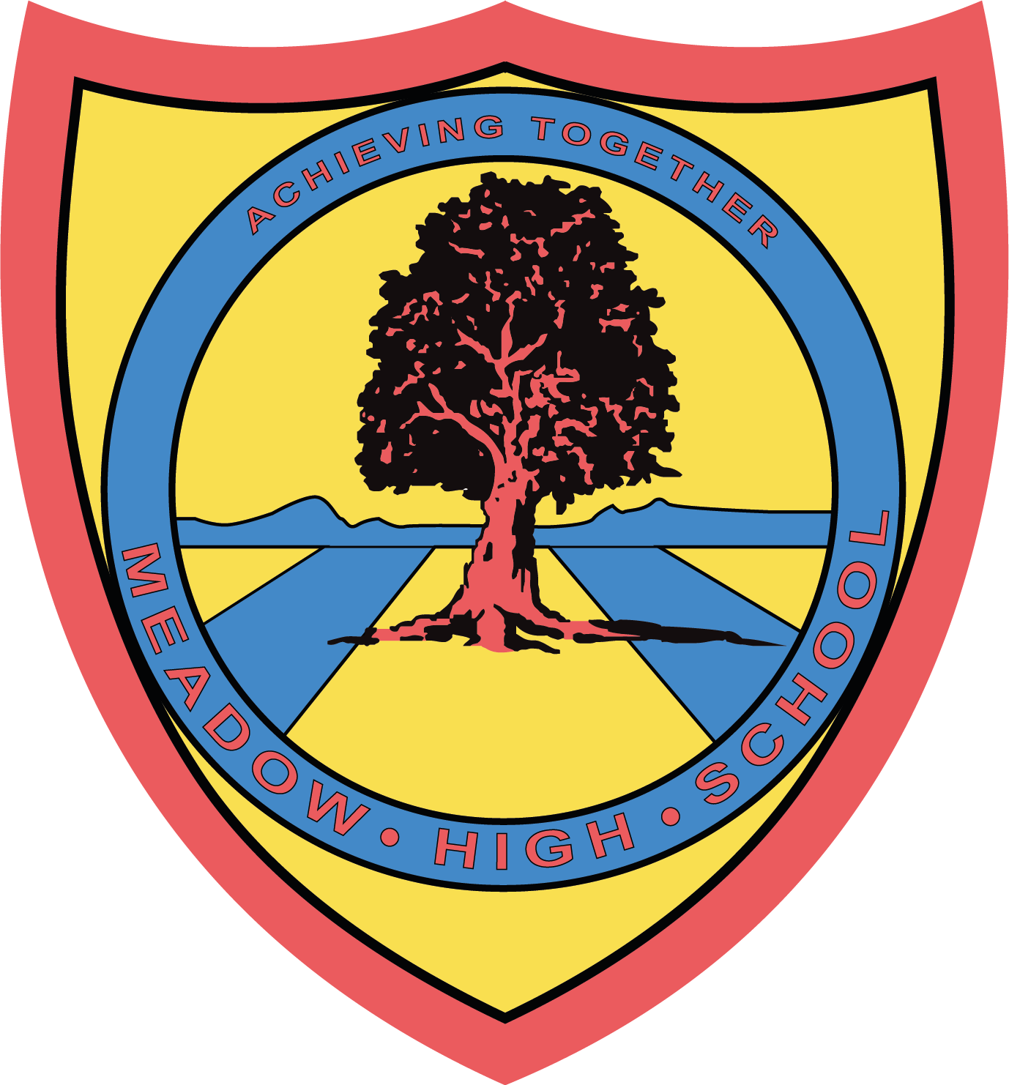

Monday 17th June 2024

Dear Parent/Carer,

To support your child with their learning to explore the community, we will be taking a trip to Go Ape on Tuesday 2nd July 2024.

We will be leaving school after registration at 9:00am and returning to school in time for transport and parent pickups at 3pm. Therefore, you will need to provide your child with a healthy packed lunch and plenty of water as well as sun cream. If your child is entitled to a free school meal, then one can be provided for them. Please indicate below if you would like a lunch provided.
We will be travelling by coach and will be accompanied by First-Aid members of staff.

We are asking for a voluntary contribution of £20, which needs to be paid via Parent Pay. Your child will require no money on the day.

Please complete the attached slip and return as soon as possible. If you have any queries, please feel free to contact me.

Yours sincerely,

Miss Krupinska

Article 23:- 'A child with a disability has the right to live a full and decent life with dignity and independence, and to play an active part in the community.'

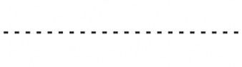
Reply-Slip: Go Ape trip on 2nd July 2024

I acknowledge that my child ………………………………………………………………………………………………….. will take part in this educational trip.
( ) I will be providing my child with a healthy packed lunch on that day.
( ) My child is entitled to a free lunch. Please provide one. Sandwich Choice: Tuna Mayo ( ) Egg Mayo ( ) Cheese ( )

( ) I will pay a voluntary contribution of £20 via Parent Pay.

Signed …………………………………………………………… Date ……………………………………………………………………
(Parent/Carer)

