Meadow High School
Royal Lane, Hillingdon, Middlesex UB8 3QU

Telephone: (01895) 443310
Email: meadow@meadowhighschool.org
Website: www.meadowhighschool.org

Headteacher: Mrs Jenny Rigby
Deputy Headteacher PW2/3: Ms Claire Caddell
Deputy Headteacher PW1: Miss Amy Willis
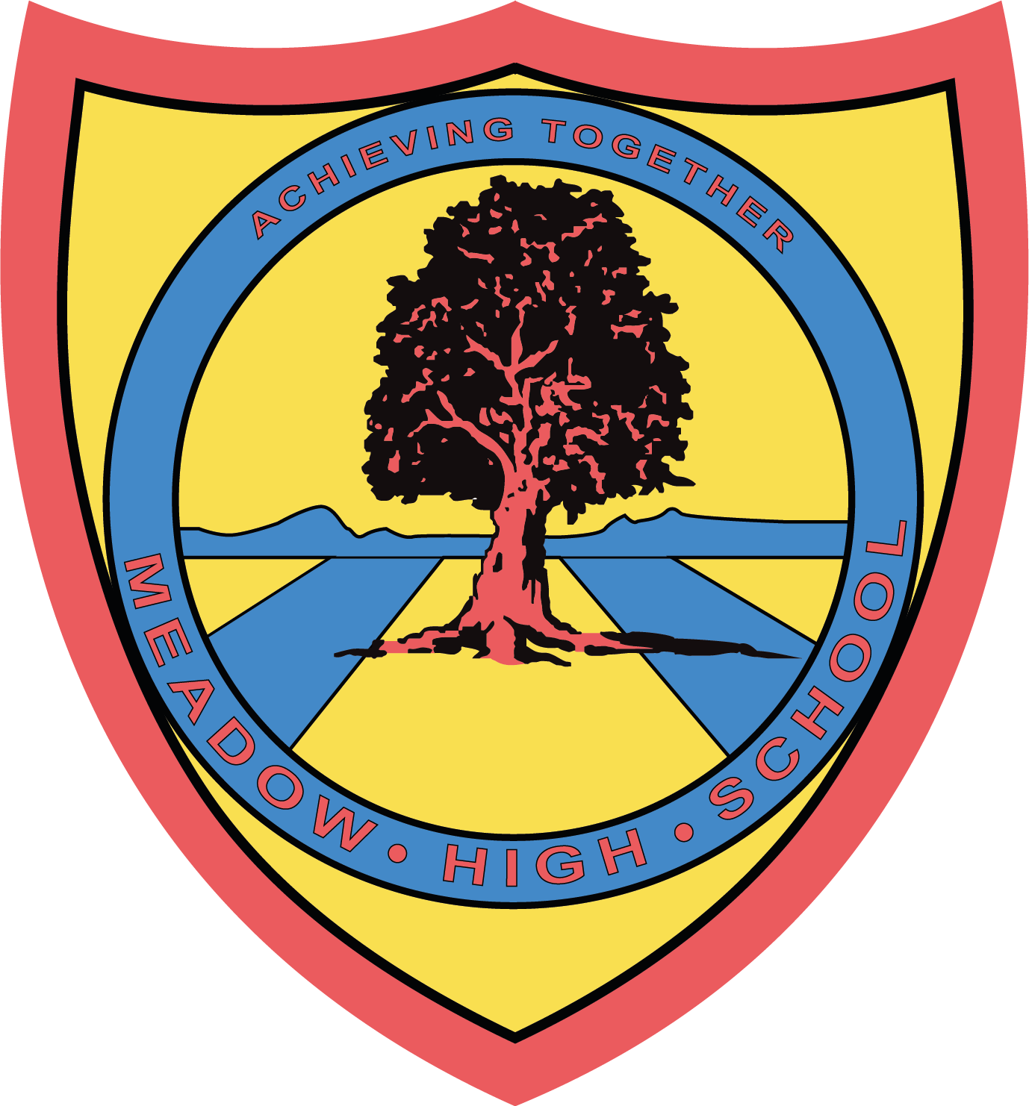

17 June 2024

Dear Parents/Carers,
Coffee Morning
Sue from DASH is coming into Meadow High School for a coffee morning to answer any questions parents may have regarding PIP, Benefits or grants.

Date: Thursday 20th June
Time: 9.30am – 10.30am (please sign in at reception)

Please let us know if you will be attending by emailing me at kwalsh@meadowhighschool.org

Tea/ Coffee and biscuits will be provided.

If you have any questions please let me know.

Kind Regards

Keri Walsh
Welfare Lead

Article 23:- 'A child with a disability has the right to live a full and decent life with dignity and independence, and to play an active part in the community.'


