Meadow High School
Royal Lane, Hillingdon, Middlesex UB8 3QU

Telephone: (01895) 443310
Email: meadow@meadowhighschool.org
Website: www.meadowhighschool.org

Headteacher: Mrs Jenny Rigby
Deputy Headteacher (Royal Lane): Miss Michelle Taylor
Deputy Headteacher (Northwood Road): Miss Amy Willis
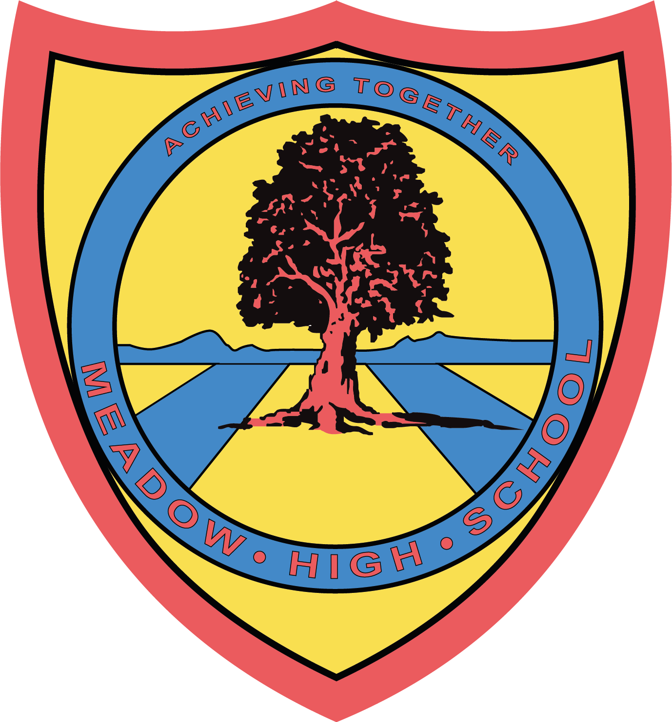

12th February 2025

Dear Parents / Carers,
Brentford FC CST: Para Talent Pathway
The Football Association has a programme called England Para Talent Pathway; it is a program that helps players with specific impairments develop their skills to aspire to play for the England Para squad. In details:
- Football ability: No previous skill is required to start training at an England Para squad Hub .
- Impairments: To include players with cerebral palsy, visual, or hearing impairments .
- Goal: To find players with the potential to play for England, even if they are "hidden" in mainstream clubs .
Brentford FC Community Trust is an accredited centre for the England Para Talent Pathway, and we often organise England Para Talent ID days .
That means I can forward students with cerebral palsy, visual, or hearing impairments to the proper centre so they can start playing football and aspire to be national England Players .
You can find more information at:
- Video of one of our PARA Talent ID Day: https://www.youtube.com/watch?v=q1hsFsOR75I
- England Para Talent pathway TheFA website: https://www.englandfootball.com/play/Disability-Football/England-Para-Talent-Pathway
If you have any players who could start this pathway, please do not hesitate to message me. I can then come at Meadow Special School to follow up.

All the best!

Kind regards,
Antonio Scicchitano (AccessAbility Project Coordinator)



Article 23:- 'A child with a disability has the right to live a full and decent life with dignity and independence, and to play an active part in the community.'


