Meadow High School
Royal Lane, Hillingdon, Middlesex UB8 3QU

Telephone: (01895) 443310
Email: meadow@meadowhighschool.org
Website: www.meadowhighschool.org

Headteacher: Mrs Jenny Rigby
Deputy Headteacher PW2/3: Ms Claire Caddell
Deputy Headteacher PW1: Miss Amy Willis
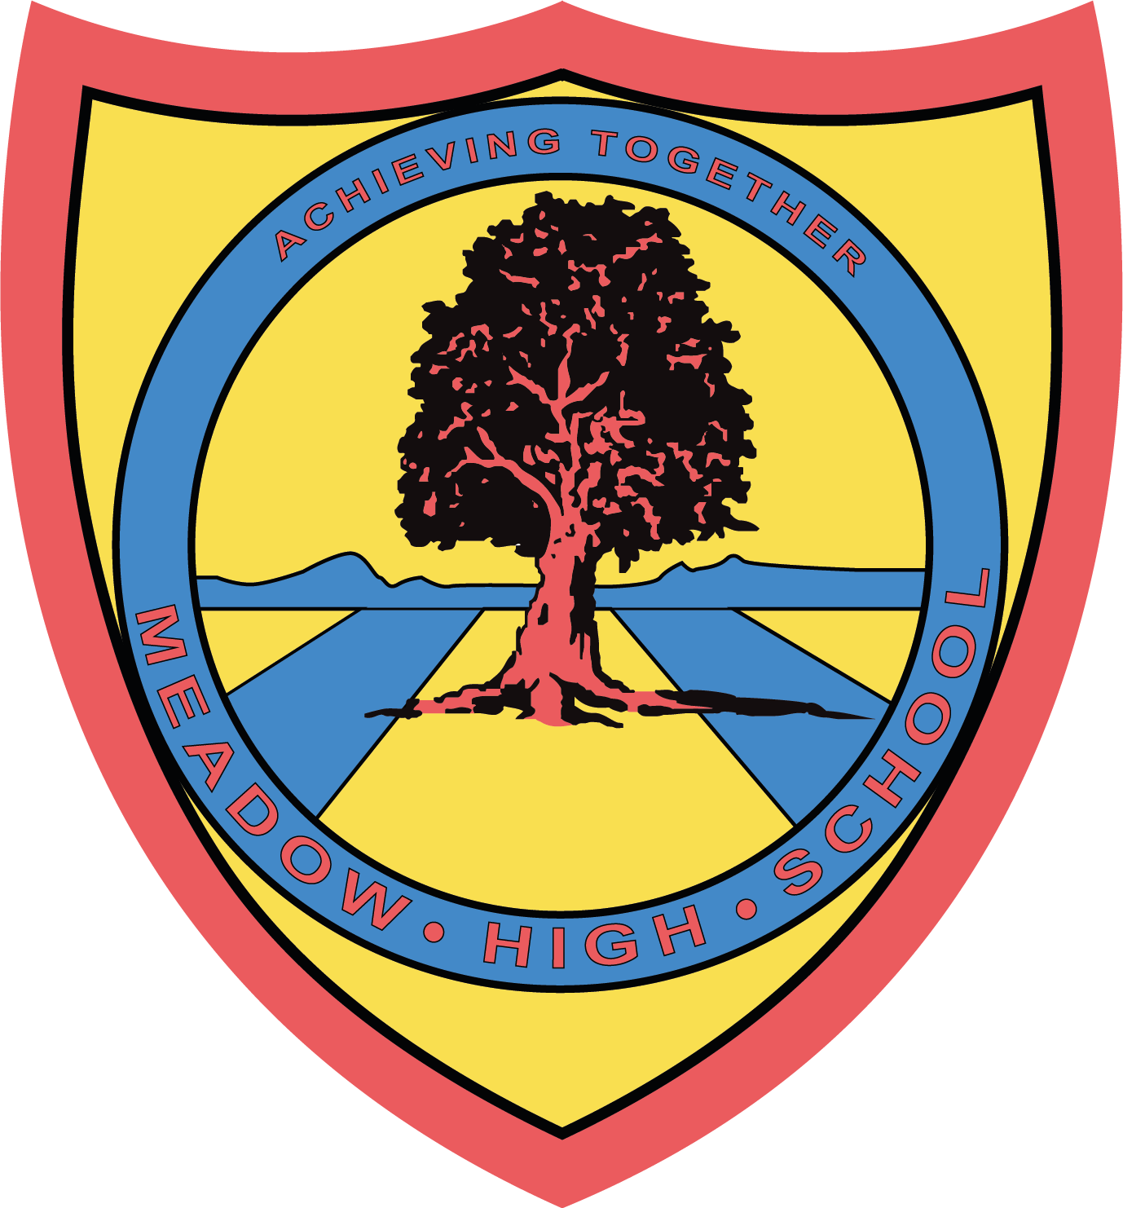

7th June 2024

Dear Parents/Carers,

Airport Bowling – Thursday 18th July 2024

On Thursday 18th July 2024, class SS will be going to Airport Bowls for the morning. In addition to spending time with their friends, they will be building on their social skills and kind sportsmanship.

We will be leaving school straight after registration and returning to school at 12.40 pm in time for normal lunch arrangements at school.

Students are required to wear school uniforms.

The cost of this trip is £4.50, if you are able to contribute, please pay on Parent Pay (this is voluntary).

Yours faithfully,

Miss Sewell
KS3 Form Tutor

Article 23:- 'A child with a disability has the right to live a full and decent life with dignity and independence, and to play an active part in the community.'


