
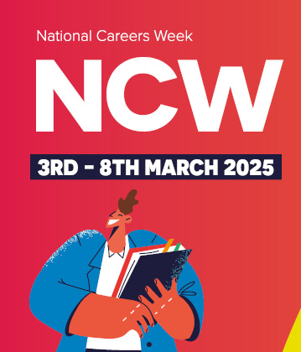
Meadow High School
Royal Lane, Hillingdon, Middlesex UB8 3QU

Telephone: (01895) 443310
Email: meadow@meadowhighschool.org
Website: www.meadowhighschool.org

Headteacher: Mrs Jenny Rigby
Deputy Headteacher (Royal Lane): Miss Taylor
Deputy Headteacher (Northwood Road): Miss Amy Willis

27th February 2025
Dear Parents/Carers,

Re: World Book Day & Careers Week: Monday 3rd – Friday 7th March 2025
Curriculum link PE Faculty – Healthy Choices, Communication + Resilience

World Book Day and Careers Week is nearly here! As always, we use this as a fun way to promote core literacy and communication skills as well as build links with to life beyond school. This year marks the 30th World Book Day since it was created and it is celebrated in over 100 countries.

To support our students in building the skills and knowledge needed for life beyond Meadow, this year we are teaming up with the PE Faculty to focus on how staying active and taking part in sports can have a positive impact on your life. We have a wide range of events planned to ensure that all students have an opportunity to build awareness of the world of work and discuss their aspirations for the future. During the week students will

- take part in a competition to research and explain who their sporting hero is
- take part in a range of job related activities with some very special visitors from the world of work
- have fun building fitness and team work skills in a giant inflatable obstacle course
- visit our library to hear staff reading some of the World Book Day books and join us at lunchtime for film club [check out our YouTube channel, Meadow High School Hello, too!]
- join in an special assembly, collect their World Book Day book and new class reading corner books
- take part in a non-uniform day on Thursday 6th March – the theme is sport and sporting heroes . OR come dressed as a favourite character from a story or for a job they are interested in.



We hope that the students all have a fantastic week!

Yours faithfully,

Mrs. Sugden Mrs. Tudor Miss Gaafar Mr Anstee
on behalf of the on behalf of the MHS Librarian on behalf of the
English & Communication Faculty Vocational Faculty Supporting & Delivering Learning PE Faculty

