Meadow High School
Royal Lane, Hillingdon, Middlesex UB8 3QU

Telephone: (01895) 443310
Email: meadow@meadowhighschool.org
Website: www.meadowhighschool.org

Headteacher: Mrs Jenny Rigby
Deputy Headteacher PW2/3: Ms Claire Caddell
Deputy Headteacher PW1: Miss Amy Willis
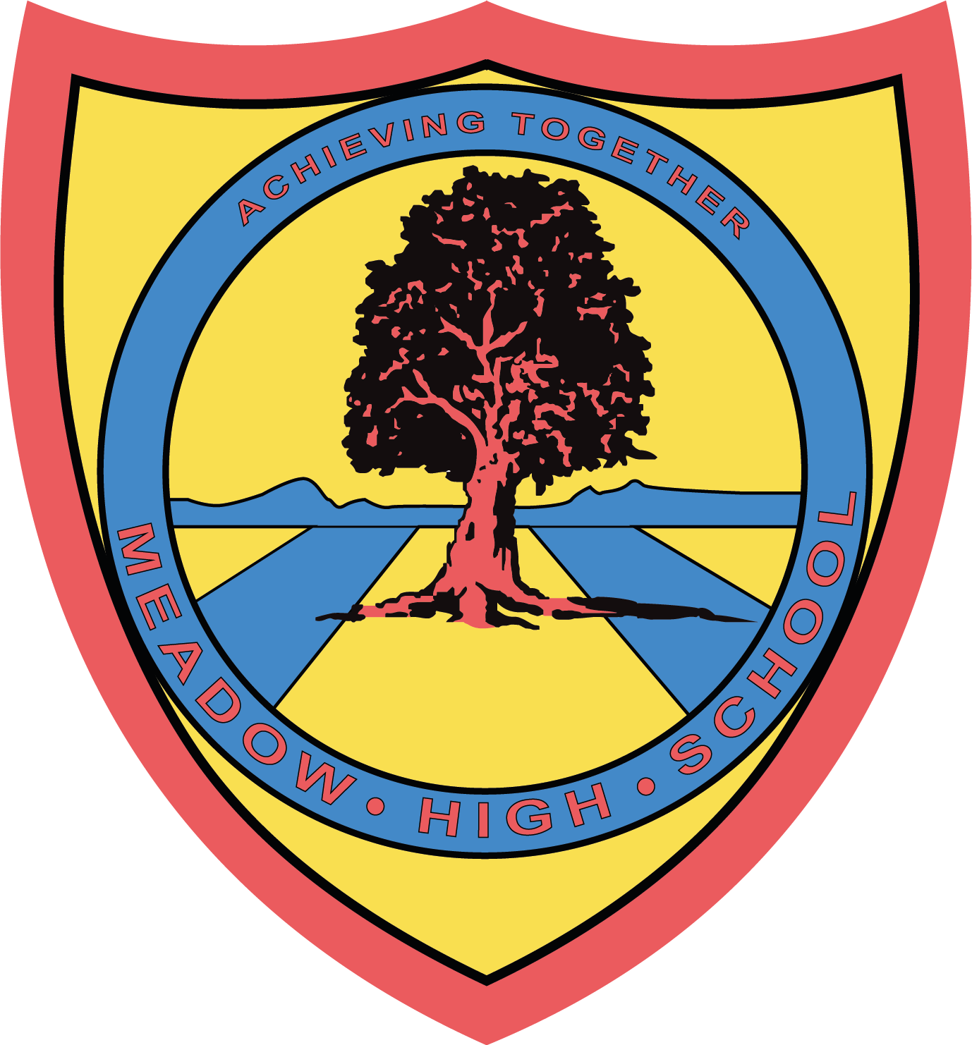

08th July 2024

Dear parents/carers,
Vocational Pathways & Work Experience:
Meadow High school offers a wide range of Vocational Pathways as part of a school curriculum to Sixth form pupils so that they can learn and develop essential employability skills. Most of these skills are transferable in supporting a pupil's increased independence. All Sixth form students will continue to participate in various Vocational Pathways one day per week in the new academic year.
Every student will receive a detailed induction programme to enable them to perform each pathway safely and ensure they fully understand their roles and responsibilities. All these pathways are delivered under close supervision and guidance of our experienced school staff. Where possible students who are independent travellers (or parents/carers who can support travel arrangements) and are confident with completing work experience outside of school, can be placed in the community and we encourage and support them to do so.
Please read the brief description of some of these pathways:-
On-site pathways:
1. Tuck shop: Students run a school tuck shop at break time and serve hot food/drinks.
Tasks involved: Setting up, cleaning and sanitising the tables, setting up equipment for the shop such as food warmer, toastie maker, induction hob and smoothie maker. Preparing hot dogs (halal and normal) and cheese toasties. Displaying items such as water, juice, hot drink cups, tissues and so on ready for sale. Counting the cash tin, selling food to the students and staff and maintaining overall good standards of hygiene.
2. Site-team: Students are also great at supporting our school site team by doing different jobs within school.
Tasks involved: Distributing resources such as printing paper, paper towels, anti-bacterial wipes, blue tissue roll, facial tissues around the school. Provide support with various cleaning tasks such as window cleaning, litter picking etc. Support with site inspections, assisting the site team with deliveries and any other tasks as requested/directed by the site team.
3. Crunchy-Munchy: Students prepare fresh food for the school staff as part of their Catering Assistant pathway. (This pathway may not be available in the Autumn term due to ongoing cafe construction in the Sixth form hall).
Tasks involved: Buying ingredients from the local supermarket and preparing and serving the meal as per the recipe. Time management - Prepare the meal by the given time, packing the cooked meal into containers and ready for collection, delivering food to the designated staffroom, tidying up the kitchen and maintaining high levels of food hygiene standards.
4. Office/administrative/receptionist:
Tasks involved: Archiving, managing school display boards, creating posters, any others resources requested by school staff such as information for school charity events, budgeting - calculating expenses and sales from the shopping and sales receipts, creating spreadsheets, learning to do emails including attachments, CC, BCC and General office/admin tasks such as laminating, printing, scanning, distributing letters to the classes and maintaining school notice boards.
5. Enterprise: Students produce quality items during these sessions which can be sold in the school Charity shop or at event sales within the school such as Christmas, Mother’s day, Valentine’s day and so on. Students are able to learn the use of technology such as sublimation printers for mug printing. This pathway will involve lots of researching, planning, organising, budgeting and being creative.
6. Hairdressing: Students support running a hair salon for the school staff and students.
Tasks involved: Setting up the salon for customers, making appointments, meet and greet customers, money handling, assisting the hairdresser instructor (Teacher), tidying up the hair salon and equipment and following health and safety rules at all times.
7. Library Assistant: Students support the librarian with the day to day running of the school library.
Tasks involved: Tidying the library ready for use by staff & students, using their alphabetical skills to place borrowed books back on the shelves, meeting & greeting visitors, directing visitors to specific resources, checking books in & out, searching the digital library system for books, creating displays for ‘new reads’.
8. Vehicle cleaning: Students carry out general cleaning of the school vehicles (mini-buses and 7/9-seater cars) from inside with the staff full support delivering good standards of service.
9. General cleaning (House kitchen/staffroom/student common room): Students will carry out general cleaning tasks in various areas, to build their practical skills, life skills and independence.
Off-site pathways - These pathways are supported by the school staff.
1. Iver Environment centre (IEC) in Uxbridge and Rural Activities Garden Centre (RAGC) in Stockley: Students volunteer on a weekly basis at these local community centres. They complete various tasks delegated to them and they work as part of a team with other members of staff/volunteers.
Tasks involved: General maintenance of grounds and site, sowing seeds according to the weather, maintaining and watering the plants, following health and safety rules and learning to use different gardening tools.
2. Heathrow Special Needs Farm, West Drayton: On a weekly basis, our students support farm staff in general maintenance of their site, collecting fresh eggs, cleaning/preparing animals cages and preparing (cutting/chopping) food for animals and following health and safety rules at all times.
3. The Burroughs (care home in West Drayton): Students volunteer at the local care home and carry out general tasks as given by the care home staff, such as; setting up/clearing tables, making beds, supporting the site team with various tasks and assisting the laundry team.
4. Shopping assistant:- Students learn to shop in the local supermarkets focusing on essential skills such as money management, buying fresh food, bagging items correctly, following the shop layout effectively to pick items, buying items that are value for money, asking for help from the shop staff and so on.
5. Oasis Soft play, Uxbridge:- Students volunteer at the soft play and carry out tasks as assigned by the manager. Students help to set up for sessions/parties, preparation of the soft play area, assist Oasis staff in the cafe, meet and greet guests and general cleaning of the site.
Please note - All of the above pathways (on-site and off-site) may differ from term -to-term due to various factors and your child will be likely to explore different pathways. Students will be rotating these pathways every term to gain experience of various occupations.
External work experience:
Students who are confident to work in the local community and are able to make independent travel arrangements, can complete work experience on individual work placements such as local garden centres, cafes, shops and so on. These placements will be term-time only and with a minimum of 4 hours per week (one day as per school timetable). These work placement opportunities are individualised depending on the student's interest and are supported by qualified job coaches as required.
Please feel free to discuss this with your child so that they understand the purpose of these pathways and benefits they will gain by participating. Your child will be completing the choice form in school for these pathways and we will endeavour to ensure that your child is given the opportunity to experience their choices.
Kind regards,
Vocational Team

Article 23:- 'A child with a disability has the right to live a full and decent life with dignity and independence, and to play an active part in the community.'


