Meadow High School
Royal Lane, Hillingdon, Middlesex UB8 3QU

Telephone: (01895) 443310
Email: meadow@meadowhighschool.org
Website: www.meadowhighschool.org

Headteacher: Mrs Jenny Rigby
Deputy Headteacher (Royal Lane): Miss Michelle Taylor
Deputy Headteacher (Northwood Road): Miss Amy Willis
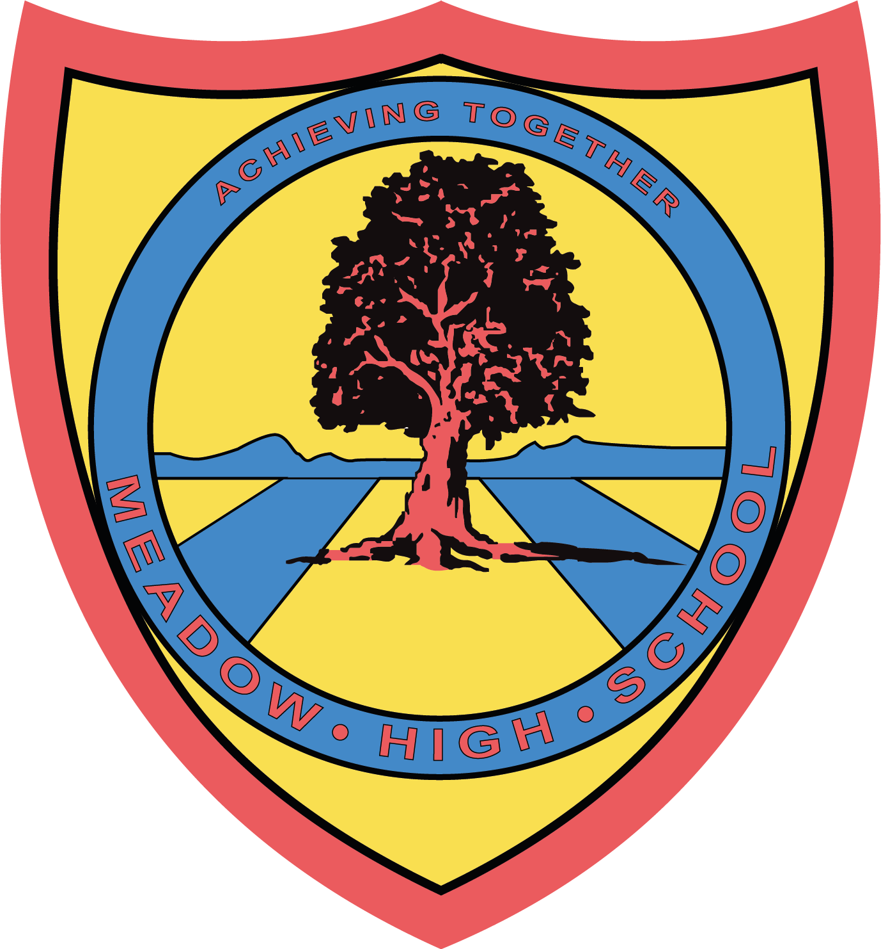

January 2024

Dear Parent/Carer,

For their Unit Award in Food Technology pupils in Year 11 will be focusing on 4-6 units of work, with a range of different cooked products. Pupils will be taking part in some theory lessons to further their understanding of Health and Safety in the kitchen and practical lessons where they will be building up their confidence towards everyday cooking.

Pupils will also take part in sensory evaluations of various foods. If you wish your child to take home the products that he/she prepares, the amount required for the practical and taste testing lessons will be £10.00 for each Term.

In order to save administration time, we would like the cost of your child’s Food Technology practical work to be paid all at once, however if this causes a problem could you please let us know and we can arrange weekly payments. If you need assistance with your Parent Pay account, please contact Reception.

Thank you in advance.

Food Technology Department

Article 23:- 'A child with a disability has the right to live a full and decent life with dignity and independence, and to play an active part in the community.'



