Meadow High School
Royal Lane, Hillingdon, Middlesex UB8 3QU

Telephone: (01895) 443310
Email: meadow@meadowhighschool.org
Website: www.meadowhighschool.org

Headteacher: Mrs Jenny Rigby
Deputy Headteacher PW2/3: Ms Claire Caddell
Deputy Headteacher PW1: Miss Amy Willis
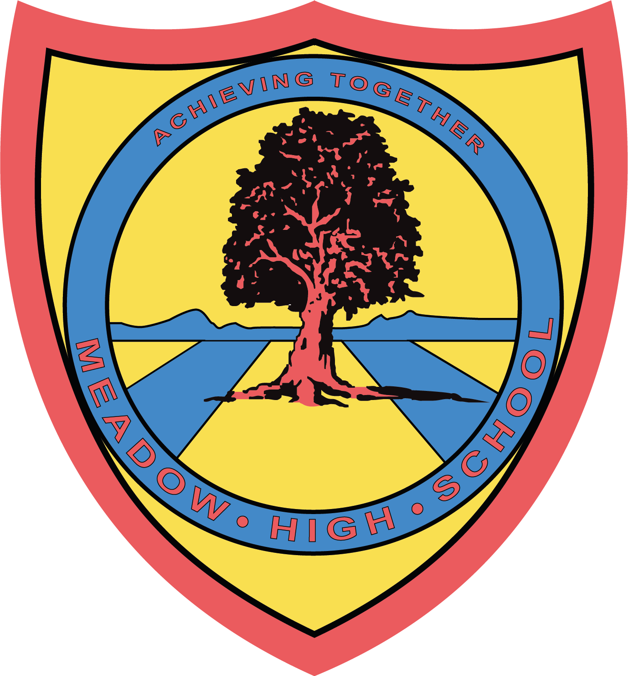

15th July 2024

Dear Parents/Carers,

I am writing to inform you that your child will be visiting Tesco in Yiewsley on 16/07/2024 as part of the Career’s visit to a local employer.

The site address is -
Tesco
High Street
West Drayton UB7 7FP

Students and school staff members will leave school around 9:50am on the school minibus and will be returning to school by 12:45pm. During the visit, students will have an opportunity to learn about the working environment, tour the site, build knowledge of various job roles, meet with their staff working in different departments and complete practical tasks with Tesco staff. Students might get an opportunity to buy small treats at the end of the visit, if they wish to. Students can bring in a small change for their own purchases. This trip is free of charge and doesn’t require any contribution.

Should you have any questions, please do not hesitate to email me on: skabhoo@meadowschool.co.uk or call school on 01895 443310 ext. 244
Yours Sincerely,

Mrs Kabhoo
Trip Organiser

Article 23:- 'A child with a disability has the right to live a full and decent life with dignity and independence, and to play an active part in the community.'

_____________________________________________________________________________________
Reply-Slip: Tesco Photo Permission
Please sign and return this slip if you give permission for the photo to be taken by the school and hosting organisation for their internal and external publication purposes.

Child name: ________________________________________ Form: ____________

Parent name: __________________________________

Signature of parent: ____________________________ Date: ______________

