Meadow High School
Royal Lane, Hillingdon, Middlesex UB8 3QU

Telephone: (01895) 443310
Email: meadow@meadowhighschool.org
Website: www.meadowhighschool.org

Headteacher: Mrs Jenny Rigby
Deputy Headteacher PW2/3: Ms Claire Caddell
Deputy Headteacher PW1: Miss Amy Willis
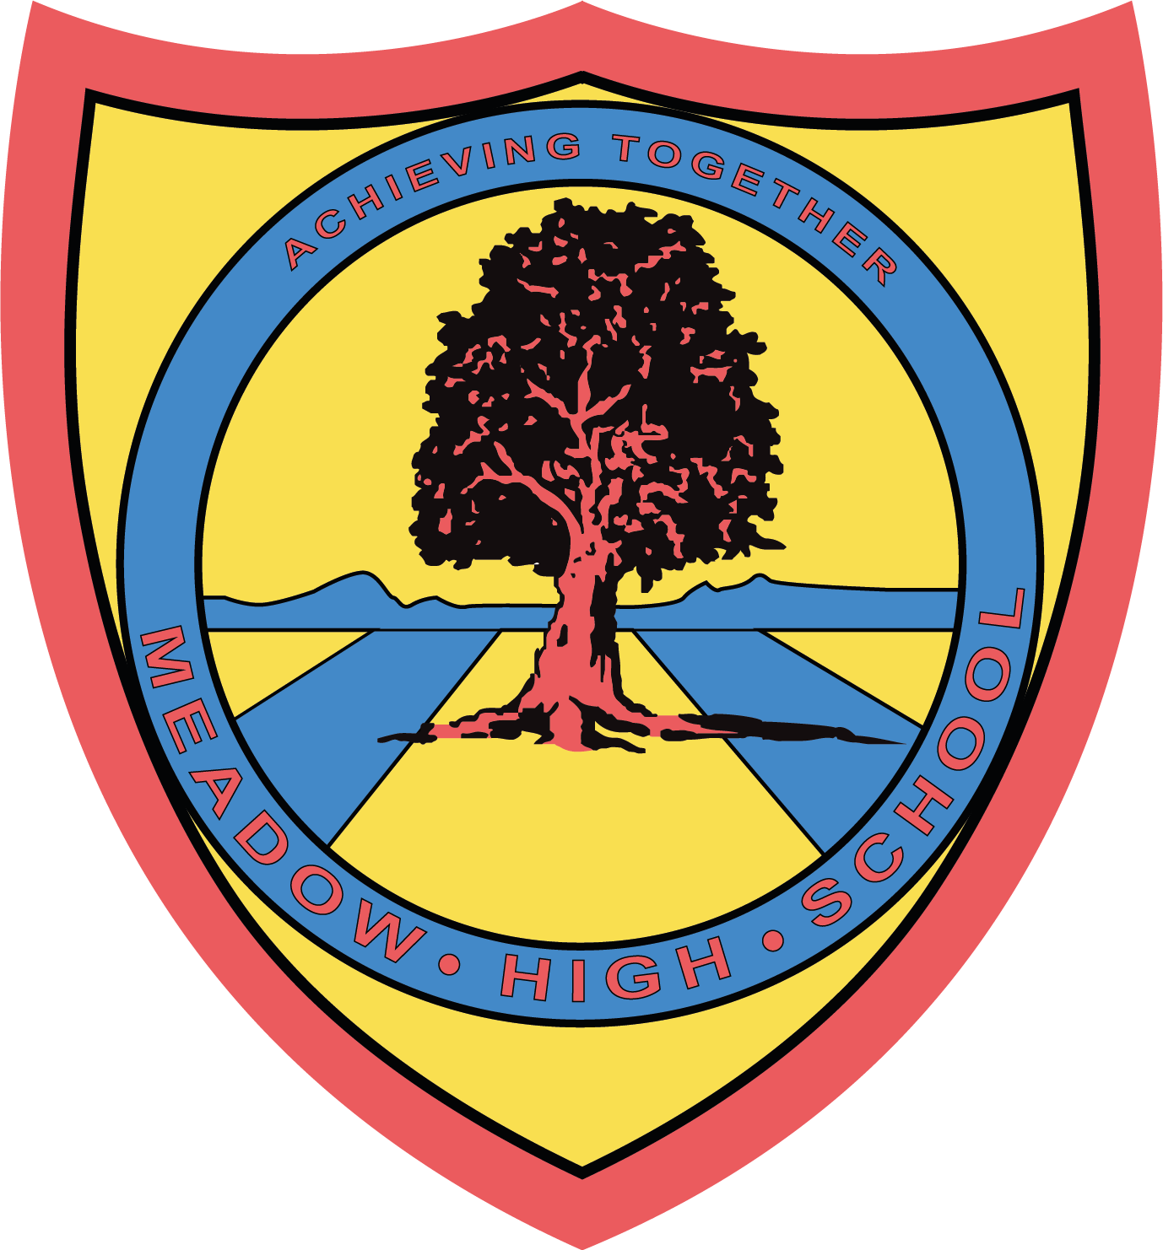

4th June 2024

Dear Parents/Carers,

Trip to Pizza Hut, Hayes

As part of our learning Personal development, we are taking part in an eating out experience at Pizza Hut on Wednesday 12th June 2024. This experience will support the learning of having a balanced diet by using the options from the buffet to make their own balanced plate.

This will also support our work within PSHE looking at developing our social skills.

We will be leaving school at 11:25 am and will return to school after lunch in time for normal transport home. We will be travelling by school mini bus and first aiders will accompany us.

Please complete the attached slip into school by 9th June 2024.

If you have any enquiries, please feel free to contact me smajidi@meadowhighschool.org.

Yours sincerely,

Mrs S Majidi
Form Tutor

Article 23:- 'A child with a disability has the right to live a full and decent life with dignity and independence, and to play an active part in the community.'

…….……………………………………………………………………………………………………………….
Reply-Slip – SM Class trip to Pizza Hut

I give my permission for ………………………………………….…to take part in the above trip.

Dietary requirements: ………………………………………………………………………………………

Signed (Parent/Carer): …………………………………………………….. Date ……………….

Emergency contact number: ………………………………………………………

