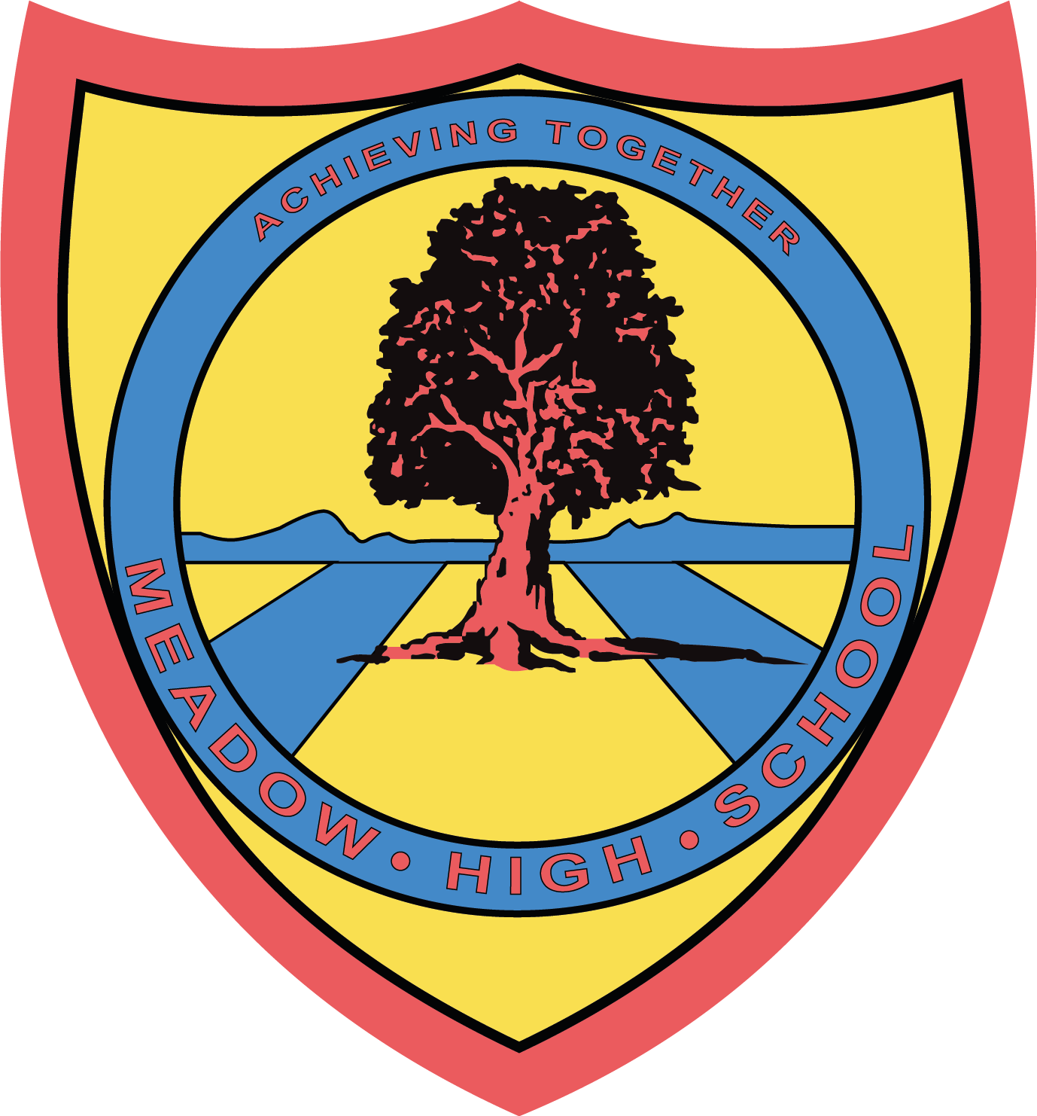

9th January 2025

Dear Parents/Carers,

Pupils in Year 10 class have been working towards their Bronze Duke of Edinburgh Award. To achieve the full award pupils are required to undertake a 2 day, 1 night expedition.

We are arranging two expeditions to cater for the number of young people ready to take on this adventure. The first one is planned for  **19th and 20th June 2025.** We have 8 spaces available. We have more pupils than spaces so, if not attending this expedition, another will run in either September 2025 or June 2026 to ensure all pupils achieve the award.

The expedition will occur at Rickmansworth Canoe Sports Trust for two days undertaking water sports, including canoeing, kayaking and paddle boarding (pupils do not need to be able to swim). Pupils will then ‘camp’ (in the classroom/school field) on the Thursday night. They will also be cooking their own food for dinner on the Thursday evening (if needed food can be supplied from home).

It is a great opportunity for pupils to undertake a new challenge and push themselves. Familiar staff from school will support throughout the duration of the expedition. All pupils' needs will be discussed in advance with families to ensure everyone is supported and feeling confident to undertake the expedition.

Unfortunately, if the young people do not attend an expedition, they won't achieve the full award. They will still receive their Bronze Duke of Edinburgh Award for the sections they have achieved in school but will not achieve the full accreditation.

**Please reply by 17th January** and I will inform families and pupils who will be attending on which dates.

If you have any questions or concerns please contact [fbonnar@meadowhighschool.org](mailto:fbonnar@meadowhighschool.org)

Many thanks,



**Faye Bonnar**

**Assistant Head Pathway 1**

***Article 23:- 'A child with a disability has the right to live a full and decent life with dignity and independence, and to play an active part in the community.'***



**Return slip – Duke of Edinburgh – please return to Miss F Bonnar or email** [**fbonnar@meadowhighschool.org**](mailto:fbonnar@meadowhighschool.org)



*I would like ___________________________________ (pupils name) to attend the 2 day,*

*1 night expedition in June 2025.*



*I am keen for ___________________________________ (pupils name) to attend an expedition but would prefer to be on the second list in Sept 2025/June 2026.*



*I am not interested in ___________________________________ (pupils name) attending any expedition.*

*Signed _____________________________________ (Parent/Carer)*

