Meadow High School
Royal Lane, Hillingdon, Middlesex UB8 3QU

Telephone: (01895) 443310
Email: meadow@meadowhighschool.org
Website: www.meadowhighschool.org

Headteacher: Mrs Jenny Rigby
Deputy Headteacher (Royal Lane): Miss Michelle Taylor
Deputy Headteacher (Northwood Road): Miss Amy Willis
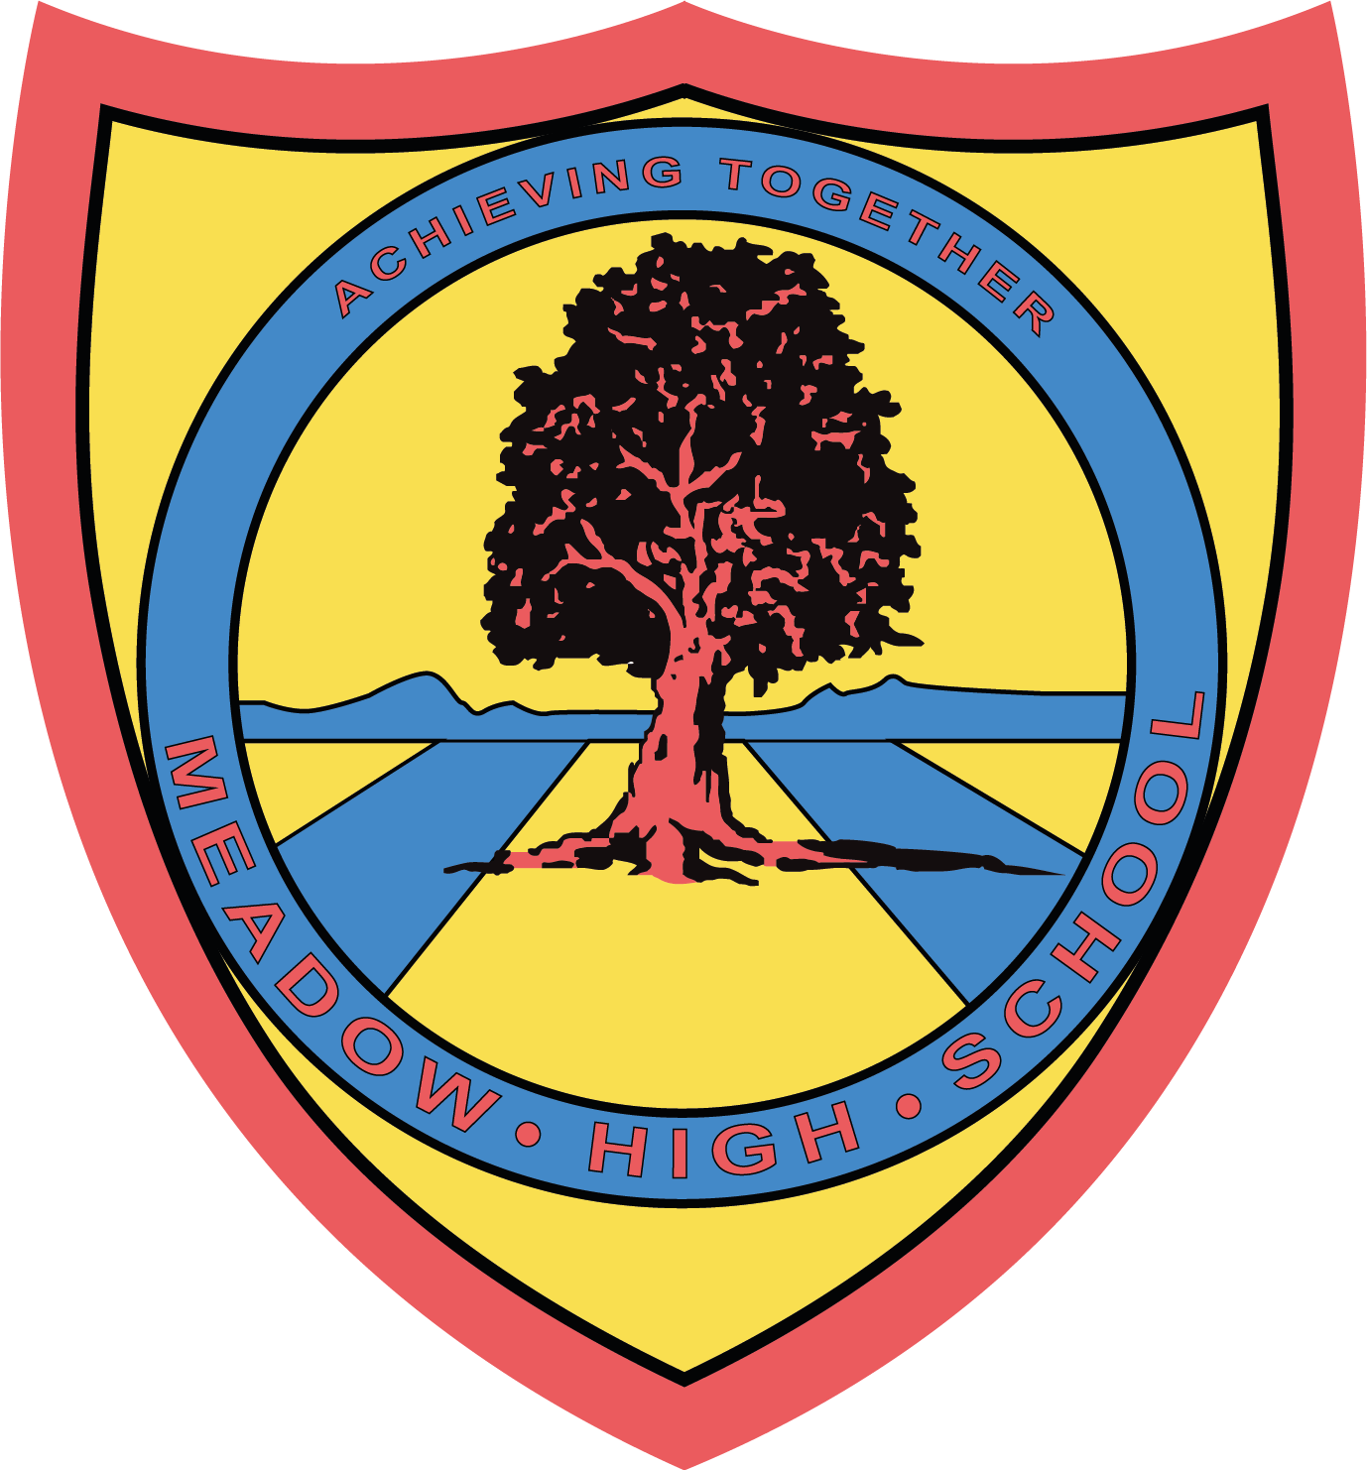

12 September 2024

Dear Parents/Carers,

As part of the Duke of the Edinburgh Award, we have a group of pupils who have the opportunity to attend swimming sessions at Chalfont Leisure Centre. This will occur each Friday starting from 20th September 2024. Pupils will travel via school minibus. Lessons will be taught by a qualified swim teacher from the centre. Pupils will require a suitable swimming costume/shorts, a towel and any other personal preferences when swimming such as googles.

Yours sincerely,

Jennie Evans
Class Teacher Pathway 1

Article 23:- 'A child with a disability has the right to live a full and decent life with dignity and independence, and to play an active part in the community.'


